CONSTRUCTIONISM: A NEW OPPORTUNITY FOR ELEMENTARY SCIENCE EDUCATION
A Proposal to
The National Science Foundation
from
MASSACHUSETTS INSTITUTE OF TECHNOLOGY
The Media Laboratory
The Epistemology and Learning Group
Seymour Papert, Principal Investigator
Submitted November, 1986
ABSTRACT

CONSTRUCTIONISM: A NEW OPPORTUNITY FOR ELEMENTARY SCIENCE EDUCATION
The word constructionism is a mnemonic for two aspects of the theory of science education underlying this proposal. From constructivist theories of psychology we take a view of learning as a reconstruction rather than as a transmission of knowledge. From a rich body of educational experience we take the view that learning is particularly effective when it is embedded in an activity the learner experiences as constructing a meaningful product (for example, a work of art, a functioning machine, a research report or a computer program).
The work proposed here is part of a long-term theoretical and applied enterprise of simultaneously developing constructionist theory and building and evaluating constructionist educational practice.
Specifically, we propose to develop a set of materials to support science activities in the elementary school, and to evaluate and study the use of these materials in various educational settings.
- These materials are designed to be usable as incremental additions to ongoing science programs. As such they will allow schools to make better use of computer technologies in order to produce significant incremental improvements in performance and in the appeal of science to children who have been kept away from traditional science learning by factors related to gender, cultural background and science-poor family micro-cultures. One level of evaluation bears on this kind of use.
- The individual materials are also designed to fit together into a larger whole so as to produce qualitative change in the way science is learned, in the way science is integrated into learning as a whole and ultimately in the structure of the entire learning process. A second level of evaluation analyzes this kind of use to generate new educational visions.
- The materials are also designed to inform theoretical study not only of the cognitive underpinnings of science education, but also of the extra-cognitive (e.g. affective, cultural and gender-related) facets of learning science.
The applied work is an extension of an advanced experimental school project created with over 2 million dollars of support from private industry. This ongoing project, operated in collaboration with Boston Public Schools, is based in an inner city, largely minority, elementary school (The Hennigan School) in which there is a high-density computer presence partially simulating the mid-1990s.
We shall make use of an observational and evaluational methodology and a large data base of student performance and profiles developed in our work at the Hennigan School. This proposal is also informed by a model for dissemination in a three-year cycle going from research idea to mass distribution which we have developed and used in our collaboration with industrial sponsors.

TABLE OF CONTENTS
SECTION | PAGE
SECTION 1. PROJECT BACKGROUND | 1
1.1. Critical Issues Addressed by the Project | 1
1.2. Conceptual Framework of the Project | 4
1.2.1. Fundamental Research and Practical Materials | 4
1.2.2. Products of the Work | 5
1.2.3. The Choice of New Topics | 7
1.2.4. Theoretical Foundation: Constructionism | 8
1.2.5. A Pragmatic Model: Lego-Logo | 10
1.2.6. Relation of This Proposal to Previous Work on Logo | 13
SECTION 2. PROJECT COMPONENTS | 19
2.1. Goal | 19
2.2. Objectives | 19
2.3. Project Design | 21
2.3.1. Project Activities | 22
2.3.1.1. Development Activities | 23
2.3.1.2. Research Environment for the Work | 29
2.3.2. Management Plan | 30
2.3.3. Project Time Line | 31
2.4. Expected Project Impact | 32
2.5. Dissemination Plan | 33
SECTION 3. EVALUATION PLAN | 34
3.1. Background to an Evaluation Methodology | 34
3.2. Application of the Methodology | 35
3.3. Evaluation Plan of Present Project | 36
3.3.1. Individual Products | 36
3.3.2. Evaluation of the Ensemble | 37
3.3.3. Our Social Goals | 38
3.4. Procedures | 38
SECTION 4. PERSONNEL | 39
SECTION 5. BUDGET | 41
SECTION 6. PROJECT RESOURCES | 44
APPENDICES:
Appendix 1: Bibliography | 46
Appendix 2: Vitae | 47
Appendix 3: Related Publications | 48

CONSTRUCTIONISM: A NEW OPPORTUNITY FOR ELEMENTARY SCIENCE EDUCATION

SECTION 1. PROJECT BACKGROUND

1.1 Critical Issues Addressed by the Project

ISSUE #1: What Science Should a Child Learn?
This project takes very seriously the question: What science should be learned by children who are now preparing themselves for adulthood in the 21st century? Surely the answer need not be a traditional curriculum with additions to bring it up to date. Yet attempts to update the science curriculum proceed by small additions and inevitably end up accentuating the impression of an incoherent "grab-bag". Yet the very essence of science is intellectual coherence.
The work proposed here is based on the observation that the growth of science and technology makes new demands on science education but also offers it new opportunities.
Among the considerations are the following:
- Changes in the need for knowledge. It has become commonplace that preparation for citizenship requires increasingly sophisticated and increasingly flexible knowledge.
- Changes in the knowledge base which could be learned. The sum total of knowledge from which the curriculum designer can select has changed -- new scientific discoveries have been made and some ideas thought to be true and important have been abandoned.
- Changes in the nature of scientific activity. The computer offers a "third wing" in addition to the "theoretical" and "experimental" wings of traditional science. Moreover the computer offers new ways to envision, to represent and to manipulate data as well as models.
- Changes in the conditions for learning. New theoretical understanding of the learning process, new technologies for learning environments, new social conditions all change the conditions for learning.
The largest component of the content of the learning which our research is designed to support is "traditional knowledge" -- we are developing new approaches to giving children access to knowledge that would have been quite familiar to a 19th-century scientist and in many cases even to Galileo.
A second component, smaller in extent but critically important in the perspective we present here, is knowledge in fields such as computation, information theory and control theory that have not in the past been considered seriously for inclusion in elementary school science.
Knowledge about computation and the sciences of information have a special role as forces for change in education. Such knowledge is important in its own right. It is doubly important because it has a reflexive quality -- it facilitates other knowledge. For example, understanding ideas related to simulations facilitates the use of computers as intellectual tools. Understanding control theory provides a wider conceptual context for the study of change and motion; and in this context the traditionally difficult to grasp laws of motion in physics become more approachable. Tools for representation facilitate thinking about ideas and situations that might otherwise be hard to hold in mind.
The reflexive quality of information science offers a solution to the apparent impossibility of adding another component to an already full school day. If some knowledge facilitates other knowledge, then, in a beautifully paradoxical way, more can mean less. The idea that learning more science and math means necessarily learning less of something else shows a wrong conception of the integration of these subjects into knowledge and cultures. They should be supportive of other learning. It should be possible to integrate in the same time blocks, learning of science, mathematics, art, writing and other subjects. If two pieces of knowledge are mutually supportive it might be easier to learn both than to learn either alone.

ISSUE #2: Need to Provide Children (and Teachers) With a Conceptual Framework For Science
This need comes from two sources. First, we have conducted studies that show dangerous weaknesses in the way children understand scientific metaconcepts. For example, many children in one study thought that "theory" meant "not true" as in the English usage "that's just a theory". Second, changes in thinking about methodology of science have put more emphasis on qualitative reasoning, on simulations, microworlds and other computational modes of understanding, and on the cluster of concepts associated with names like Kuhn, Toulmin, Feyerabend; but these trends in thinking about the nature of science have not yet been assimilated by school science.

ISSUE #3: Need for New Knowledge About Differences in How Children Learn: Culture, Gender and Individual Psychology
Advances in cognitive science have given new insights into the general process of learning. They have so far been less informative about differences in how and what children learn, especially in the areas of science and mathematics.
Our work gives special importance to individual, cultural and gender differences among children. We have shown how to open domains of knowledge to students who have traditionally not been able to master them. We are looking for much stronger results in this direction. We also expect the theoretical underpinnings (in cognitive and in personality psychology) of this work to grow -- allowing us to increase our depth of understanding, to become more self-critical, and to articulate with other trends of thought.
Our work has already taken a big step toward re-interpreting reports in literature of gender differences in attitudes and feelings about computers and their use. We can show that these affects, while real, are responses not to computers, but to computer cultures, to the way computers are integrated into the school. In our experimental school, we observe radically different patterns. These differences are partly attributable to the higher density of computers, partly to the attention we have paid to culture formation and partly due to factors we have not been able to identify.

ISSUE #4: Need for Better Understanding of the Affective, Aesthetic and Cultural Aspects of Learning Science
One ounce of knowledge about how to encourage children to fall in love with science might be worth ten pounds of more effective ways to teach students who are indifferent -- or worse -- to what they are learning. Teachers, magazines, science museums, TV producers and many others try their best. But rigorous research on science education has emphasized the cognitive side -- how science is understood rather than how it is -- or is not -- loved.

ISSUE #5: Need to Make Science Attractive to Children of Both Genders from Science-Poor Social and Family Backgrounds
National potential is dependent on being able to mobilize the talent of all sections of the population. Yet many children grow up under conditions that are extremely poor in laying foundations for interest in and capacity for doing (or even appreciating) science and engineering.

ISSUE #6: Need to Re-Assess the Opportunity for Integration of Science With Other School Learning
The new technologies open enormously richer opportunities than existed previously for the integration of science not only with mathematics but with the total curriculum including the arts (literary, visual and musical) and the increasingly important learning of meta-knowledge. Opportunities for integration offer a solution to the problem of doing anything new in already over-scheduled schools.

ISSUE #7: Need to Study Non-Incremental Educational Change in the Context of High Density Presence of Computers and Highly Developed Computer Cultures
Reports in the past few years on the crisis in education have not appreciated the full potential of new information technologies as a context for educational change. We hope to demonstrate that more improvement is possible than is envisaged by these reports. One will not ever understand the possible extent of the computer impact in schools by repetitive studies of the effects of computational materials designed for use by students and teachers who have little computational experience. We intend to focus on the study of how students learn with computers when they have already had many hundreds of hours of computer experience spread over several years of their lives.
Furthermore, as long as all experiments in education are incremental, (that is, for example, adding computers a few at a time to an otherwise unchanged school system), we cannot know what the ultimate limits of change are. Technology did not go from the horse wagon to the space shuttle by increments of one horsepower at a time.

1.2 Conceptual Framework of the Project
We discuss the conceptual framework of this project under the following headings:
- 1.2.1 Fundamental Research and Practical Materials
- 1.2.2 Products of the Work
- 1.2.3 Choice of New Topics for Science in Elementary School
- 1.2.4 Theoretical Foundation: Constructionism
- 1.2.5 A Pragmatic Model: Lego-Logo
- 1.2.6 Relation to Past Work on Logo

1.2.1 Fundamental Research and Practical Materials
It is necessary to define how we place ourselves in relation to the frequently used separation of "R" and "D".
This proposal describes a three-year plan for research and development aimed at redesigning a significant segment of elementary education to take advantage of the technologies and the supporting cultures one can expect to see in schools in the early 1990s. The research proposed will implement and test our belief that with new technologies one can very significantly extend the range of what is considered to be learnable by students at given ages and with given psychological profiles.
Our laboratory has developed a methodology of work in which the development of materials, implementation in schools and the conduct of fundamental research are unusually closely linked. Consider Logo for example. Where other groups of educational psychologists who wished to study children's programming have been content to study what children do with existing programming languages, we developed a new language -- and when we found that limitations of Logo biased the study of certain research questions we developed very different versions of the language. Similarly, when we suspected that some of the research findings about children's reactions to computers are the manifestation of the way the computer presence is implemented in schools rather than of anything invariant in the relationship of computers, children and learning, we set out to create very different implementations in experimental school settings.
The same methodology of work guides the design of the present project. Our driving interest is fundamental research to guide long term change in education. But this kind of fundamental research requires the production and implementation of educational materials. Take a simple example of work we propose to do. There has been considerable study by cognitive psychologists of what has come to be called misconceptions in physics, for example of the effect of a force on a moving object. There has been some study on the influence of some very limited computer based experiences (such as dynaturtles) on these misconceptions. Our approach to this issue is qualitatively different and much more demanding. We see the way children think about force as integral to an extensive network of concepts and experiences -- indeed it is integral to something broad enough to be called a culture. To study the conditions under which it might change requires more than putting a child for a few hours in front of a computer simulation of a Newtonian world. It requires creating an intellectual environment permeated with a set of "pro-Newtonian" ideas and perspectives and watching children in this environment perhaps over several years. Thus it requires going beyond the "psychology lab scale" of experiment; it requires experiments on an "educational scale." And such experiments require the production of workable educational materials, the training of teachers to use them, the extensive observation of children and the analysis of the learning experience.
Thus, our approach to research requires that we also do work that is usually classified as "development of materials". We need the materials to conduct our own experiments. But three reasons operate to suggest that we should also make the materials in a disseminable form:
- marginal cost is small (less than 5%);
- wide use of materials can give valuable research data;
- a sense of being in the real world is good for education researchers.

1.2.2 Products of the Work
We conceptualize the products of our proposed work in three categories: "scientific knowledge," "educational materials," and "educational vision."
Scientific Knowledge: The scientific knowledge will represent a significant step forward in a theoretical approach to education we have developed over the years. The central ideas of this theoretical approach are outlined in Section 1.2.4 under the heading "Theoretical Foundation: Constructionism." The scientific knowledge we hope to produce will also include empirical findings relevant to our thesis that many categories of students who have not done well at science in the past can in fact learn science very successfully, and those who already learn science successfully could learn very much more. In Section 6 (Project Resources) we describe a context of work in an inner city experimental school project where we have been engaged for some time studying how to make science attractive and accessible to children from science-poor social backgrounds, to disadvantaged children in general, to children who seem to be kept from science by gender-related factors and by students whose intellectual style is so mismatched with that of traditional school methods that they are classified as "learning disabled". We also work with "advanced work classes" made up of relatively successful students.
Educational Materials: The educational materials we plan to produce are designed to be usable through the 1990s. Their full power will emerge only in a technological context where students will have greater access to more powerful computers than exists in today's schools. More essentially their full power will require a "computer culture" in which students and teachers have a deeper and different understanding of computation than one finds in today's schools. However, the greater part of our materials will be designed to operate, though at reduced power, in today's schools. Our design strategy is in marked contrast with the way much educational software is being produced today which is designed for use in a primitive computational environment and will be obsolete in the computer culture that is just around the corner.
In this proposal "materials" refers to modules that could be packaged as self-contained commercially saleable products. These products would be made up of software, print, hardware and optical media in varying proportions. At the extreme of greatest simplicity, our modules will consist simply of booklets describing in a form accessible to teachers how to use existing computers, software and other classroom equipment to implement new activities. At the extreme of greatest complexity we will be working towards the development of new computer languages (or extensions of existing languages): the products in which these are embodied would be elaborate systems including, in addition to software and reference manuals, extensive materials for teacher training.
Educational Vision: The phrase "educational vision" should counteract a possible impression of fragmentation given by the discussion of separate modules of materials and of scientific knowledge. The phrase refers to the whole that will make the parts greater than their sum. The set of modules will be used by educators in many ways, undoubtedly in many cases without change in the overall vision of science education in the elementary school. But the set of materials we make will be designed to carry a vision of science learning as very different from the way it now takes place in schools. And in addition to the production of particular materials and the conduct of particular evaluational and other studies, we shall engage in activities directed at elaborating and communicating this vision. Central to these activities is our participation in school-based projects where we try to set the example of using our materials in conformity with the larger vision.
We plan a series of books to present to a broad public what we are doing, and we are discussing with possible producers the production of video materials suitable for specialized and mass diffusion.

1.2.3 The Choice of New Topics
Our PI has been engaged with many colleagues over nearly two decades in a search for new focal areas for study at elementary school. It is easy to make a long list of topics in science that would be "nice for children to know". But making long lists of topics has been the intellectual undoing of science education: the essence of science is intellectual coherence and nothing undermines this more than the "grab bag" effect produced when each member of a committee throws in a personal contribution of favorite pieces of knowledge. Our goal is to find a small number of topics of study which will generate, to a maximal degree, a sense of what science is about, a taste for doing it and a technical mastery of some fundamental ways of thinking. Ideal topics for early study of science are not necessarily those the student will "need" in later life, but rather those that will place a student in a position to be able to acquire any specific knowledge with relative ease when it is needed. In our search we have considered both "new knowledge" -- areas of science that have only recently come into being -- and recasting old knowledge.
In the work we do here we shall concentrate on three areas of study:

Information Science
This includes "information processing" in the sense of programming, data structures, etc. It includes very elementary forms of cognitive modelling and related subjects. It includes topics from control theory and communication theory. We show below that this area has preeminent reflexive qualities that give support to much other learning within and without the boundaries of "science."
We note as a factor that played a role in choosing this area of activity that it touches on many objects in which today's children are intensely interested. Apart from computers as such, these include video and audio equipment of all sorts, machines that talk, etc. A strong argument for including the study of these objects is analogous to the reason for the considerable attention many schools give to animals. Children like working with animals and working with them can bring the young mind into contact with important ways of knowing: and all this in a context where social responsibility, ethical and relational issues are present in a warm supportive whole. It would be absurd to suggest replacing animals. But similar factors support the study of informational objects -- even the social and human ones if the way they are studied is designed properly.

Motion Science
Information science is an example of "new knowledge" while motion science is an example of "recasting traditional knowledge". It includes parts of physics ("pre-dynamics") and of mathematics ("intuitive calculus") that become accessible at a much earlier age because they can be supported by the work on information sciences. For example, control theory provides a concrete "hands-on" foundation for the concept of "laws of motion".
Motion Science includes topics in biology (e.g. "how animals move") based on simulations and motion segments stored on optical media.
As it is presented here, motion science overlaps areas, for example art and drama, that are not normally counted as part of science. But we believe that softening this boundary is advantageous for science education.

Color Science
Color has a much more modest status in the hierarchy of science than the other two topics: Taken in its largest sense, informatics could lay claim to be what is most new in our historic period while dynamics has occupied center stage at least since the time of Galileo. The importance of these "prestigious" departments of science is easy to justify. But why Color?
We hope that it will become apparent in the following pages that Color is a wonderful example of several principles that inform our thinking. It is tremendously important to children. It has rich sensory qualities. Mastering the use of color in the context of computer graphics allows children with an "artistic" or "sensuous" bent to appropriate a piece of science as a personal instrument. And we can recast the study of color in a form that makes it a carrier for mathematics and science that are close to center stage. For example: The "three-color theory" represents colors in a three-dimensional vector space; using this representation in a programmable microworld allows children to appropriate the idea of vector space.

1.2.4 Theoretical Foundation: Constructionism
A central theme of this project is represented by the term Constructionism, which has been conceived to describe a major thrust of our past and present research activities.
Constructionism is a synthesis of the constructivist theory of developmental psychology (See Bibliography, "Constructivism and Piaget," 1964, 1970, 1972, 1978) and the opportunities offered by technology to base education for science and mathematics on activities in which students work towards the construction of an intelligible entity rather than on the acquisition of knowledge and facts without a context in which they can be immediately used and understood.
A central feature of constructionism is that it goes beyond what is usually called "the cognitive" to include social and affective facets of mathematics and science education. This feature leads us to a new approach to understanding and penetrating educational barriers related to gender, to cultural factors prevalent in many American minority groups and to personality issues that are often classified as learning disabilities.
Our approach to affectivity is illustrated by a principle we call "appropriation", which places first priority on children making science their own. Much of our research is based on the working hypothesis that children (like anyone else) will learn science best if they use it. We do not mean by this that they can use it "when they grow up." We mean that they should be able to use it right now. And we do not mean that they use it only to perform activities imposed on them by teachers. We mean that they use it for purposes they experience as their own.
As an example of what this means consider a child who is in love with, and expert at, visual arts. In the traditional school setting such a child can quite easily come to perceive science as personally irrelevant. But this situation could change. Certain technologies would be able to make this child an offer he or she can't refuse: For example, a computer graphics system that would open doors to artistic goals. The simple fact of using a piece of advanced technology can be enough to change a child's relationship to things technical and so to science.
But there is a more powerful and specific "offer" where using the machine for artistic creation exercises scientific skills. We have seen a number of cases where Logo graphics plays this role. For example Turkle (1984) describes a case of a fourth grade girl who progressed quite deeply into Logo out of artistic motivations although her previous school record did not suggest a technical disposition of mind. But Logo graphics merely scratches the surface of what could be done.
Our initial experiences with Lego-Logo (See Section 1.2.5 and Papert, 1986) provide more examples in the same spirit. A well documented situation is how the problem of designing Lego racing vehicles leads directly into questions about the relation between weight and rate of descent on an inclined plane: most children begin with the intuition that weight is the primary determinant of how fast something will fall and discover for themselves (and because they care) that this is not so.
In summary, Constructionism goes beyond (while including) the idea of hands-on. For example the children building the Lego vehicle or the art work on the computer screen have their hands on the job, but the fact that the children are working to make something, and especially the fact that they are making something they believe in, adds extra dimensions.
Constructionism also goes beyond (while again including) the cognitivist principle that underlying deep structures are central to learning science. To the cognitive deep structures it adds a number of other deep dimensions: affective, aesthetic and socio-cultural to which we give at least as much weight as the cognitive factors. There is no reason to discuss whether the affective dimensions should get more weight than the cognitive, but it is not implausible that the most important factor in learning science is falling in love with it -- a student who WANTS to do science will find ways to learn it; a student who hates it will resist all the cognitive cleverness the most sophisticated teaching can bring to bear. Einstein remarked that love is a better master than duty.

1.2.5 A Pragmatic Model: Lego-Logo
We use here as an example of our recent work in the constructionist direction a project called Lego-Logo. This project encapsulates key elements of our theoretical approach, and it also represents the style of relationship we are attempting to build with the world of schools, with the world of informal education, with the education industry and with the general public interested in education.
The idea of working with Lego construction materials developed out of two interests. Work with Sherry Turkle had deepened our understanding of and interest in the role in learning of intense relationships children form with objects, and construction sets seemed to be a very good context in which to pursue these interests. At the same time (1983/4) the idea of developing motion as a major theme of study in K-12 was taking firmer shape and it seemed clear that "real" moving objects as well as computational ones should be included in the activities to be developed. Since we are generally biased towards a methodology in which children would make rather than be provided with the objects they study, construction kits were an obvious choice here too. A survey of available construction kits converged rapidly on the choice of Lego both for technical reasons and because getting to know the people at the head of Inter-Lego, the Danish parent Lego company, made it very clear that they would be an ideal industrial partner.
By 1985 we had explored a number of ways Lego could be integrated into elementary education and had settled on the general form of a model in which children would begin work with simple Lego constructs and move quite quickly to building constructs that can be connected to a computer and programmed in Logo. In the school year 1985/6 we tested and developed this model first in the context of our experimental project in the Hennigan School and then under more "realistic" conditions in a number of schools in Connecticut and New York. We worked with students at grade levels 1 through 7 and at academic levels including special education classes and advanced magnet classes as well as average inner-city school classes. We tested models of teacher training. The most elaborate could be called a full apprenticeship: a teacher new to Lego would learn by assisting an expert Lego teacher for several hours a week over a whole month. The least elaborate was simply a single-day workshop backed with some written material and a videotape. When more data is in, we shall publish a comparative account of what was achieved under these different conditions.
These trials had a number of successful outcomes. On the most pragmatic level, Inter-Lego took them as sufficient proof of feasibility to decide to launch Lego-Logo as a product which will be on the market in time for the school year 1987/8. On a deeper level we did in fact find leads to a number of deeper research issues -- including questions related to gender: to everyone's surprise we found that girls easily became involved in this kind of work. The manifest interest of what was happening tempted Edith Ackermann, who was visiting from the University of Geneva, to make this her major research interest (which she will now be able to do all the more easily since we have recruited her to the faculty at MIT). It also tempted Mitchel Resnick, an extremely talented graduate student at MIT, to make the development of computer control languages for situations like Lego-Logo the topic of his thesis.
It is a hallmark of a good education project that it attracts the attention both of the pragmatic commercial world and of excellent researchers. Lego-Logo has attracted attention from other quarters as well. It has been recognized as an ideal activity for public access science centers and members of our team are working with the Boston Science Museum to develop an activity for this domain. And when presented at a number of conferences, it attracted large attendance and enthusiastic responses that promise easy dissemination and sound adoption of the product of the work.
But most important is the attention Lego-Logo attracts from children at all levels, of both genders and from all social backgrounds. Teachers observing children they know at work with it have expressed astonishment at the quality of the work. Moreover, it is their opinion that the work has had a positive effect on children's regular classroom work; our own view of this is highly optimistic but still in reserve as we continue longer term studies of the children's development.
As an indication of "science content" of the work we mention here a number of activities. The initial project is to build a car and run it down a slope in "soap-box derby" style. We note a universal spontaneous tendency to want to modify the car to improve its performance and from there an inevitable concern about what factors make something go faster. As we mentioned most children begin by treating weight as the important variable and move on after a shorter or longer time to understanding that very little can be gained by increasing, decreasing or shifting weight; the factor that matters overwhelmingly is friction. We see this experience as belonging to the same family as David Hawkins' famous "messing around" activity with a pendulum. And within that family it has the special advantage that whereas Hawkins (and Eleanor Duckworth who worked with him) had to provoke the children to be interested in the period of a pendulum, the interest here arose quite spontaneously.
Later the children move on to motorize their Lego constructs and eventually to connect them to the computer. Introducing a motor quickly raises another set of issues that belong in the traditional science curriculum. For to use the motor effectively gears or pulleys are needed and then issues arise such as mechanical advantage, trade-off of speed for torque and the phenomena of momentum and inertia.
The computer introduces issues from control theory which the reader will easily imagine. We want to turn to make a small comment on the gender issue.
We have seen enthusiasm for Lego-Logo develop in girls who had obviously been brought up to behave and think of themselves in a traditionally "feminine" way. Such girls are often reticent in the presence of anything technical and sometimes their first reaction to the Lego Room at Hennigan is quite shy. After the first assignment of building a car for the "soap-box derby" children are allowed to choose what they will do next. Such girls often choose a project that is "pretty" rather than functional. But we saw the following incident. Four girls embarked on building a house -- a traditional activity for which Lego is well-suited and well-known. Nothing new, nothing technical. Until the second week when a small light began to blink in the house under control of the simplest possible Logo program. And from the small beginning the children moved on to more elaborate uses of technology. We are examining many explanations of such behavior. One is that these girls, and very many others like them, have an inner desire to appropriate machines, science and all things technical. But they are timid. The Lego-Logo situation offered them a chance to take hold of a tiny corner of the technical world with a gentle, light touch. And once they let themselves touch it, they can feel their way in at their pace -- and, as it were, when no one is looking.
Careful and deep research may be needed to understand fully the complex processes that might lead a girl to break out of her techno-phobia and take hold, timidly at first and then firmly, of science and technology. But we already have strong evidence that many will do this.
In this proposal our Lego-Logo experience serves as a model in four respects:
- Lego-Logo is a concrete case study to support discussion of our theoretical ideas. It thereby serves as a model for other applied work that will come from our theoretical approach.
- Lego-Logo is a model for the interaction between the components of the work of our MIT laboratory: theoretical research, operating a model school, developing classroom products. One can see from it how these components are inseparable.
- The story of Lego-Logo shows in successful action a model of a three-year cycle which we propose to emulate for the exportable material products of our work. We present the cycle as made up of four phases:
$$\text{research}⟶\text{development in a special school setting}⟶\text{testing in representative school settings}⟶\text{developing commercial partnership and placement in mass market}$$
- The public response to Lego-Logo illustrates an objective of this proposal we call "Raising The Aspiration Level." (Section 2.2 Objective #3). We have found that the Lego-Logo activity can be used effectively to open the eyes of educators and the public in general to new horizons of educational possibilities.

1.2.6 Relation of This Proposal to Previous Work on Logo
It must be obvious to anyone who knows the literature on using computers to enhance education that the work proposed here is rooted in the tradition of the PI's work on Logo. On the other hand the new work differs in several respects from Papert's early work and in even larger respects from perceptions of Logo that have become widely held in education communities. This section has the double purpose of recalling some aspects of Logo that have been captured by the idea of Constructionism and giving at least a general sense of respects in which the present project should not be identified too simply with the Logo movement in general.
Although precise statistics are not available, it is safe to guess that at least a third of American elementary schools use Logo. Unsurprisingly, they do not all use it in the same way. Uses of Logo range in educational style from the most structured and traditional kind of teaching to experiments in "open" and "spontaneous" learning reminiscent of the free-school movement.
Logo was developed as an educational tool to be used in a variety of ways for different educational purposes, including the three most common uses:
- a. providing a route into programming;
- b. providing a context for learning some specific mathematics;
- c. providing a context for meta-learning of various kinds.
Our strongest advocacy of Logo is not to teach children programming for its own sake, but rather to use knowledge of programming to create the context where other learning can happen.
Logo is not always used in these ways. The design of the present project is informed by study of the wider Logo experience: it extends what have turned out to be the best uses of Logo; it sets up safeguards against repeating the poor uses of Logo.

Learning From What Went Right With Logo
When Logo is most successful as a carrier of powerful ideas in learning, we believe it is so because the particular learning environment encourages the following five facets (or dimensions) of its use.
- Pragmatics: First, children feel they are learning something they can use -- not "when you grow up," but right now. This immediate utilitarian quality is rare in school mathematics and science. We call this dimension Logo's pragmatics.
- Syntonicity: Second, the uses children find for Logo often have a very personal and intense quality, also largely absent from school math and science. This quality can take the form of personal projects, or it can take the form of Logo being used in ways that express a personal style of doing things or a personal aesthetic. The computer is being used to do something that the student experiences as important and psychologically powerful. We call this Logo's syntonic quality.
- Syntax: Third, there is Logo's syntactic dimension. The structure of Logo's formalisms makes it accessible to beginners who can progress into more complex syntactic structures gradually as they need them.
- Semantics: A fourth principle of intellectual power is semantics. With Turtle Graphics, we are not dealing with a formalistic mathematical structure in which symbols are pushed around. Statements in Turtle Graphics have meaning. In fact, they have multiple meanings. They refer to mathematically important ideas and they also refer to psychologically evocative real world situations.
- Social: Finally, a fifth dimension is social: Logo's integration into personal relationships and the culture of the environment in which it is encountered.
These five dimensions are the foundations of the approach we have named "constructionism".

Learning From What Went Wrong With Logo
In the years 1982 and 1983 Logo penetrated widely into schools in the U.S. and in other countries. As it did so a Logo community developed with representatives in schools, in industry and in research centers. Many members of this community adopted and defended Logo uncritically, even faddishly. But many others responded to the experience of widespread use by analyzing and trying to correct weaknesses that came to light. The following sample indicates the scope of the PI's personal interventions to correct weaknesses:
- a. Support Materials: A major weakness in the implementation of Logo in many schools came from the nature of the support materials provided to teachers. Although there are now over a hundred texts for students and teachers available from several dozen publishing firms, teachers do not easily find the kind of help they need in implementing Logo. Papert has argued that the weakness is not so much in the particular texts, many of which are written by extremely competent people, but in a mismatch between the traditional textbook format and the interactive nature of Logo. Attempts to correct this include working with the BBC to produce an hour-long video with an emphasis on the educational principles underlying the Logo turtle. Ethnographic interviews with many teachers who had seen "Turtle Talk" (which has been broadcast several times on US national television by Nova) showed that it was partially effective but insufficient. The next step in this direction was the production of a series of ten 30-minute tapes released late in 1986. Test trials of these tapes give good reason to predict that they will substantially improve the educational uses of Logo.
- b. Lowering Perceived Barriers: The design of Logo was informed by an ideal that can be expressed in the slogan "no threshold and no ceiling" -- it should be accessible with virtually no pre-requisites and should offer scope for development without limit. Experience with Logo on a mass scale brought into clear focus many of the ways in which it falls short of the ideal. Many variants of Logo have been developed and tested in an attempt to find ways of lowering the threshold and especially of lowering perceived barriers to going beyond using it only for graphics. One upshot of such studies is the design of an extensively revised version of Logo called LogoWriter, the first version of which was released in April 1986. The fact that within six months it was adopted by more than 2,000 schools and by one entire state (Minnesota) is providing the opportunity to sample very wide use of the new version of Logo and to confirm that it has indeed overcome many of the limitations of Logo.
- c. Expanding Application Domains: The development of Lego-Logo illustrates a third direction of work that has corrected deficiencies in the use of Logo. By providing an application of Logo which is very different in spirit from the best known use for graphics and very easily understandable by teachers, Lego-Logo makes concrete the idea of a programming language as a very general purpose educational tool rather than as a particular topic to be learned.
Improvements in the use of Logo have a bearing on the likelihood of success of the new materials proposed here. When it is well done, experience with Logo will serve as teacher preparation for the materials proposed here. In addition, the PI's experience with identifying and correcting weaknesses in the implementation of one widely used educational innovation will help reduce (nothing could completely avoid) similar "bugs" in implementing the present project.

Learning From The Evaluation Of Logo
The literature on the evaluation of Logo shows the need to pay careful attention to making some conceptual distinctions that might seem too simple to require mention.
Logo was designed and evaluated in the original studies at MIT as a building material for learning environments. The spirit of its design (and of the entire educational philosophy that informed the research group responsible for Logo) makes it quite inappropriate to ask questions such as "what are the effects of Logo on children?" and still less appropriate to ask questions such as "has Logo delivered what it promised?" (A widely quoted formulation attributed by Psychology Today and many other sources to Jan Hawkins of Bank Street College).
Logo, as such, is not an active agent that can promise or not promise, deliver or not deliver. It is an instrument that can be used by teachers and by learners. It can be used in many different ways and depending on how it is used, it can have very different kinds of effects. It is an element that can become part of a culture and will be shaped by the culture as much as it shapes it.
Carelessness in formulating the evaluative question has resulted in discrepancies in the literature. For example, Roy Pea, working at Bank Street, reported in early studies that he did not find "cognitive effects" of learning Logo. Douglas Clements does find cognitive effects. (Papers by Clements, Pea and others are cited in bibliography. See also Papert, 1985). The difference is partly in the tests used: Clements used a battery of well established tests of intellectual style and ability whereas Pea used an ad hoc test of his own invention. But a more serious reason for the difference in outcomes is that neither investigator was testing "the effects of Logo" -- both were testing what happened in a particular learning situation of which Logo happened to be a highly visible component.
The situation facing the would-be evaluator of Logo is made even more complex by (not-so-surprising) findings that even in the same learning environment different students make use of Logo in very different ways (Papert et al 1978, Papert 1985, Turkle 1984, Weir 1986). Papert has noted that on certain tests different individually beneficial effects could cancel one another in a population of students. For example some students function best using highly structured, "planned," cognitive processes while others function best in situations where they can use a more intuitive "negotiational" style. Now, it is conjectured that some versions of Logo environments for mathematics allow students a very much greater flexibility in choice of style for geometric work than does the standard school setting. Confirming this hypothesis requires that there be improvement in the quality of geometric work. But the hypothesis is consistent with a decline in the average use of structured planning. Thus if "planning" (the criterion used in Pea's original studies) is taken as the measure of good cognitive functioning, Logo could well induce a decline in cognitive function (as measured by this criterion) and yet be seen as highly beneficial intellectually from a perspective that allows the possibility of a wider range of effective cognitive styles.
And, indeed, what we consider to be the most important outcome of our own research is the demonstration that mathematics and science (including computer programming) can be successfully performed by children in a variety of cognitively and affectively different styles and the goal of presenting these subjects in a form that is flexible enough for individual students to take them up in their own intellectual styles.
We note here, in passing, that the existence of different styles of doing creative mathematics and science is obvious in the world of real science -- it is only in school that rigid conformity to a particular style is expected (Feynman, 1985).
In our view, Logo has proven itself primarily by the fact that very many good teachers have found it to be a valuable instrument for teaching. Evidence for this is given most simply in reports such as the extensive semi-ethnographic study sponsored by the Ontario Ministry of Education (Carmichael et al.). And in this spirit we read authors like Clements as showing something different from their own formulations of their work. Clements has shown one way in which Logo can be incorporated into a total learning experience that produces certain desirable changes in meta-cognitive function; we scarcely need scientific studies to show that Logo could also be incorporated into a total learning experience whose cognitive effects are negligible or negative.
These observations have led us to develop a conceptual framework for our evaluation studies of materials (such as Logo or the new materials to be developed in the project proposed here) in terms of levels:
- Level One: Verifies that materials can be used as directed and that whatever they teach explicitly is learned. For Logo this was achieved by our own early work describing achievement levels and has been widely confirmed. An analogy: evaluate a hammer by checking that people master it.
- Level Two: Evaluates use of what is learned to do other things. What is made with the hammer? Is Logo used to teach and learn Math and Science?
- Level Three: Looks at the user as an individual. What people use hammers best? Should some people stick with glue? Does using a hammer over time change people?
- Level Four: Examines the integration of materials into a variety of learning environments. This level includes any global impacts on climate of opinion, on level of aspiration and on general direction of research in a larger community than our own immediate circle. The hammer is seen as an element.

Role of Logo in Proposed Work
To appreciate the intentions of this project it is conceptually essential to separate out the PI's advocacy of Logo as a specific programming language from his advocacy of a style of using the computer. The latter is what is important. Logo is a means to an end that could be served as well by many formally different means. For example, if some of the early versions of Smalltalk were available on school computers much of what is described here could be done as well with that as with Logo, in some cases perhaps better.
(Among other candidates that have been proposed as programming languages suitable for children are PROLOG and BASIC. PROLOG has many suitable features and shares with Logo and Smalltalk the requirement of intellectual coherence and an aesthetic that reflects at least one school of serious computation theorists. However, we remain convinced that a procedural language has a better match to the needs of elementary school students. BASIC has nothing to recommend it except that it is there: it has no intellectual coherence, it is a grab-bag of assorted programming tricks -- and, moreover, happens not to include the very ones that are most useful in giving children greater power to control the computer).
Logo will be used in the projects to be developed here simply because it is the only available language that provides elementary school students with the programming power to take control of the computer. And the spirit of the work demands absolutely that the student have control, and be conscious of having control, of the computer.
But while Logo will be used, the project will not confine itself to Logo in its present commercially available forms. Quite the contrary, the objectives of the project include experimenting with new programming features in a spirit that would lead by the end of the three years to tentative designs of alternative programming languages for children to use in the last decade of the century. (See Section 2.3.1.1).

SECTION 2. PROJECT COMPONENTS

2.1 Goal
It is our intention to develop and implement an innovative model program to enhance science and mathematics education in the elementary grades, by researching, developing and implementing three new topics of study to be introduced to elementary students and teachers.

2.2 Objectives

Product Oriented Objectives:

OBJECTIVE #1: Creating Materials for Science in the Elementary School
Over the past years, we have experimented with a variety of intellectual domains that are candidates for reformulation similar to the reconceptualization behind Turtle Geometry. Out of this work, three topics have emerged. Theoretical considerations and partial implementations have shown the possibility of developing pragmatic, syntonic, syntactic, semantic, and social dimensions for each of these similar to those presented by Turtle Graphics. In addition the three topics form a synergistic, mutually reinforcing set. The proposed topics are: Motion, Color, and Information Science.
The three topics of study are not prominent in today's curricula as explicit presences. However they bring together many concepts that are or should be in the curriculum. Our rationale for exploring these particular topics is three-fold:
- The new topics will allow traditional concepts and knowledge to be learned by more students and more deeply by each student.
- They introduce new knowledge that is important for the modern world.
- They open new perspectives on theoretical and social issues in education.
Our preliminary experiences show that they bring a new energy and intellectual charge into the classroom. They make science and mathematics accessible to a very much wider range of students. And we believe they will attract enthusiasm and quality thinking in teachers.

OBJECTIVE #2: Developing a Teacher Training Plan to Support Our Materials
All materials developed will be backed by a tested model of teacher training. We will develop a series of training activities to:
- Introduce teachers in our experimental setting to the project materials as they are developed; and
- Assist teachers in implementing these materials into their classrooms.
After evaluation and testing in external classroom settings, these activities will be refined and a training model will be prepared for dissemination.

Social Objective:

OBJECTIVE #3: Raising The Aspiration Level in Education
An important part of our project in the long as well as the short term is influencing educators to understand that much more can be achieved than the present expectations of schools and of the public. We aspire to bring about understanding among educators and in the general public that more children could achieve much higher levels of mathematical and scientific knowledge and do so at much younger ages.

Research Objectives:

OBJECTIVE #4: Understanding the Roles of Affectivity and Aesthetics in Science
We have adopted as the "slogan" for this phase of our research a quotation from Einstein: "Love is a better master than duty."
Translated into a research conjecture this phrase predicts that learning ability and quality of work in any domain will go up substantially if the student "falls in love" with that domain of knowledge. Investigation of this conjecture goes hand in hand with the attempt to understand and to create the conditions that foster a student's "falling in love" with learning.

OBJECTIVE #5: Exploring the Effect of Differences in Intellectual Styles on Learning Science
The idea of intellectual styles in the way people practice as well as learn mathematics and science. We have made progress towards defining characteristics of such styles and towards developing new conceptualizations of science and mathematics curricula to fit the needs of people with different styles.
Issues of gender and culture are clarified by this research. And from it we are developing a new approach to "learning disabilities" -- we already have impressionistic evidence to support a conjecture that in many cases apparent learning disability reflects a mismatch between individual style and school methods.

OBJECTIVE #6: Developing a New Unified Theory of Science Education
The position of objectives #4 and #5 show our feeling that the "non-cognitive" side of science education needs special attention. But the point is not to eliminate the cognitive. Quite the contrary; our principal theoretical objective is to continue working towards a theory of education that will integrate cognitive with affective, aesthetic and cultural considerations in understanding and promoting learning. And apart from this ambitious goal, the project will contribute new knowledge to standard cognitive theory.

2.3 Project Design
The project will be composed of ongoing activity of theoretical research which interacts with a series of cycles during which selected science/mathematics topics outlined below will be researched, and then classroom materials emanating from these topics will be developed, implemented, evaluated, and prepared for dissemination.
Each cycle will be made up of four phases:
- Research;
- Development in a special school setting;
- Testing in representative school settings; and
- Developing a relationship with a commercial partner and effective placement in a mass market.
This design models a continuous pipeline: as the project progresses, the cycles will generate sequences of materials that will allow us to bring a stream of products to the schools according to the estimated schedule indicated on the time line.

2.3.1 Project Activities

Overview
The project is defined by five areas of activity. The driving activity is theoretical study of the epistemology of the sciences and the psychology of learning science. From this activity four others stem:
- Development of new science materials for the elementary school;
- Implementation of these materials in the following school settings suitable for testing:
  - 2.1. An advanced high computer density "school of the future" project operated by a collaboration between MIT and the Boston Public Schools (Project Headlight);
  - 2.2. A network of more representative test site schools in Boston, New York, Minnesota, Ohio, Missouri and California;
- Observation, evaluation and theoretical interpretations of these uses made of the materials;
- Dissemination of final forms of the most successful materials and of the scientific knowledge acquired through all the above activities.

2.3.1.1 Development Activities

Anticipated Educational Products to be Developed
Our research plans require us to work with products of two kinds: those that can be adapted for use in present day school settings and those that require some essential features of learning environments that cannot reliably be anticipated in the next five to ten years.
An example of the first of these two kinds is the Lego-Logo project we take here as our model. The materials needed to implement this project are in the domain of "low-tech"; e.g., an interface device that can be produced quite inexpensively, software modifications to Logo and easily available Lego materials. Moreover, using Lego-Logo a great deal can be achieved with a small number of computers. For this discussion we call such materials "immediately usable" products.
Later, we mention as examples of educational materials based on work with another kind of Lego-like product which we plan to use heavily in our own research as soon as 1987 but which would not become available to schools generally until 1990 even on the most optimistic assumptions about its (untested but strongly conjectured) value. This is a "distributed intelligence" in Lego constructs. In a project whose hardware component will be supported entirely by industry, we are constructing a Lego set in which all the "bricks" will have electrical paths (for power and for signal) built into them and some specialized bricks will house actual processors and memory. The reasons for doing this are very varied. They include the desire to keep products for children in line with what is most intellectually central in computer science (where distributed computation -- in the extreme case connectionism -- is growing in centrality). Our rationale of the project also includes a conjecture that the girls mentioned above would have related more effectively and with greater consequence to the opportunity to build intelligence directly into their house without having to connect it physically to an out-of-scale computer.
Another set of "future-oriented" products is based on using computers with color capabilities beyond those of today's school computers. In this proposal we describe a project that shows how the study of color could (and should and probably will) become an important chapter of school science. Some products of the proposed color project could be implemented on the immediately usable level. But some of it is irreducibly future-oriented. In discussing the products and impact of this project we distinguish sharply between these two types of product.
However, we must emphasize that our concept of "future-oriented" does not refer to a distant "science fiction" kind of future. Nothing we propose to do will appear unrealistic to average schools in ten years from now.
Our model for making immediately usable products closely follows the Lego-Logo three-year cycle:
- Year One: Research discussions are translated into informal educational experiments from which a small number of directions are selected for development during the late spring and summer;
- Year Two: Implementation and evaluation in the experimental school; presentations are made at conferences and discussions launched with potential publishers and/or manufacturers; schools are invited to volunteer as test sites for the next phase of evaluation; teacher training workshops are held over weekends or in the summer;
- Year Three: Feedback from the evaluations is used to make a go/no-go decision and to make improvements if it is go. There is a final round of evaluations and production of materials in publishable form;
- Year Four: The product is disseminated.
Since our experimental site is an ongoing project, the cycle of individual products need not correspond to the three years of the proposed NSF-project. Rather we think in terms of a pipeline. We already have a few product projects at each stage of maturity. Products such as Lego-Logo that are already entering their third year will contribute to the NSF project but will not draw on its resources. A small number of projects that are now in their second year and a larger number of projects now in their third year will be inherited by the NSF project. Thus, in its first year the NSF project will be working with products at each stage of maturity and as a result it will be able to produce "exportable products" as early as its second year. Products that have made substantial progress prior to the start of the present NSF project are referred to below as "Group A products." Support from the NSF is needed for these products for two kinds of reasons. Some of the projects were begun with "seed" funding and cannot be continued without new support. All of them will benefit from the extensive and thorough evaluation and dissemination activities envisaged as part of this project.
We use the designation Group A for products that are already far along the development path, Group B for products designed for present day use which will be developed with funds from this project, and Group C for future-oriented projects.

GROUP A PRODUCTS
The following products are firmly under development:
- "Children as Educational Software Designers": This project which has long antecedents in our work with Logo has been adopted by Idit Harel as the topic of her Ph.D. research and has been greatly deepened and extended by her. The idea is based on the observation that students find it highly motivating to design and implement educational software. For example Harel has carried out a pilot case study of fifth grade students who wrote programs in Logo to "explain fractions" to younger students. The students in her study appear to engage through this activity with meta-cognitive ideas: in simple-minded terms the project of formalizing an explanation of fractions leads them to think about fractions from a more distanced point of view than they do when simply carrying out exercises in fractions. Harel is now beginning a more systematic implementation and study of the idea. Her major goal is to make a contribution to scientific knowledge. But her work will have exportable spin-off products. The likely form of a first product will be "how to" manuals for teachers and students, a collection of software tools and an evaluation report.
- Student-Programmable Access to CD-ROM Data Bases: Members of the Epistemology and Learning group (graduate student Tim Walker and staff member Mario Bourgoin) are collaborating with members of other groups at the Media Technology Lab (particularly Professor Andrew Lipman and Dr. Walter Bender) on the production of a CD-ROM data base of geographic information which will be very much more freely accessible than anything that exists presently to students with knowledge of programming and information representation. A first product will certainly be a CD-ROM disc and associated software tools, print materials, etc. suitable for use at all levels in schools. The ultimate goal is deeper understanding of how to integrate massive data bases into educational environments.
- Use of Logo-Based Animation in Elementary School Science and Mathematics: The use of Logo as a tool in science education has been limited in part by the restriction of most Logo work to static drawings. New versions of Logo as well as new ideas about how to use Logo have opened rich possibilities of using student-programmed animated simulations. At the Hennigan School such animation has been used in biological simulations (e.g., the respiratory system) and in astronomical simulations (e.g., the planets). At the District Three Computer School in New York, Logo animation has been used as an integral part of a study unit on time. Simply reporting these uses of Logo has enlarged the horizons of some teachers who were looking for more powerful ways to use computers in science. The production of better explanatory materials including more examples and perhaps some software tools will greatly increase the value and accessibility of these projects. One of our graduate students, Judy Sachter, has the background in computer animation and in teaching experience needed to carry out this project.
- Guidance Systems: Student-programmed devices whose motions are guided by feedback were a focus of interest in the early work at MIT on Logo. However the idea did not reach critical mass until Lego made possible the construction of a wide variety of controllable devices. The timeliness of the topic is further supported by new research on children's concepts of motion and on the prominence in the world of guided devices. The anticipated product consists of materials that will provide wide experience with guidance, feedback and other ideas from control theory and use these as an intuitive stepping stone to understanding laws of motion in physics. The research side of the project will likely lead to a new approach to the interpretation of children's understanding (or as some like to say, "misunderstanding") of motion. A graduate student, Mitchel Resnick, with a degree in physics has adopted a closely related theme for his thesis research.

GROUP B AND C PRODUCTS
These topics cannot be as clearly spelled out as the group A projects on which work is already far advanced. The following indications show the directions of our tentative agenda. In each case it will be apparent that a full study has a long-term future-oriented component that belongs in category C. However we expect each of the following topics to have spin-off products in category B.
- Development of Curriculum Modules for Information Sciences:
Our tentative list of topics in Information Science is:
  - Programming
  - Control Engineering
  - Code Theory
  - Communication Engineering
Programming is one topic that has been extensively discussed in the context of school planning. However the conditions of the next decade will call for reconsideration of current ideas. We separate two kinds of reconsideration. The first is quantitative -- it has to do with how much children can learn. We are already seeing at the Hennigan School children learning far more than is usually considered possible. The second is qualitative -- it has to do with shifts in what "programming" means. Important sectors of the computer science community think of programming in terms of object-oriented languages; the concept of multi-processing and parallelism have grown into new frontiers known by names such as "connectionism"; interface design is leading to a proliferation of ideas about what programming will look and feel like to the user. In this context, Logo is already old-fashioned; it will be obsolete in five to ten years as will every other language that has been used to date in education. Moreover the new science topics we are developing both demand and, reflexively, support the learning of new forms of programming language.
Two talented graduate students in our group (Mitchel Resnick and John Bennett) are currently exploring as research topics for their theses aspects of new forms of programming. We expect others to join them. Our prediction is that in two years from now we shall be in possession of data from close observation of students bearing on implementation of a range of "partial languages" and shall be ready to engage in discussion with the larger computers-in-education community about the issues that must inform the design of languages for the end of the century.
These "partial languages" will provide data on the use of the following features:
  - object-oriented programs
  - message-passing systems
  - declarative programs
  - multi-processing languages
Control Engineering is the extension and generalization of our work in Lego-Logo. Resnick's work actually lies in this domain as much as in programming -- he is using Lego-Logo as a microworld in which to explore new directions in programming language. Edith Ackermann devotes a considerable part of her research energy to studying the psychological side of work in this area. Sherry Turkle and Seymour Papert are engaged in a collaborative study of the role of interactive objects in the development of children's knowledge. That this area is attractive to researchers is seen both from this study, and from the interest in other research groups aroused by our work. We also note that the idea of connecting computers to "real world" devices is resonant with the excitement aroused by Robert Tinker and the MBL idea which however is being developed in a more scientifically traditional spirit than our work.
Code Theory in a narrow sense refers to Shannon-style "theory of information" and in a wide sense encompasses the whole field of representation. We pitch it in between. Preliminary studies have shown that many children are attracted to activities related to codes. Using computers opens much larger areas for exploration. We have some preliminary results in turning algebraic ideas underlying code theory into an appropriable instrument for children. We have also explored children's general interest in computational representation. We see this as an area of work with a high degree of reflexivity.
Communications: This area draws on the others as a conceptual foundation for the study of the video and audio devices that are increasingly present in children's lives. At present few children even begin to be able to answer quite simple questions like: why can't we have more TV channels? What do the picture adjustment controls on a TV set actually do?
- Motion Science: The Study of Motion and Change:
Here we can anticipate a "Group B" product for which extensive trials have taken place at the Hennigan School, at the New York District Three Computer School and elsewhere. The concept is to give children from the earliest ages control over motion in the way that the Logo Turtle gives them control over certain forms of graphics. The means of control are "pro-Newtonian" in that they encourage and make concrete such ideas as controlling motion by working with accelerations rather than by working with successive positions or even directly with velocities. We note that this is quite different from older work in which objects such as "dynaturtles" simulate a Newtonian world. Here we are constructing microworlds in which children can make their own laws of motion rather than simulations of specific laws of motion. We have theoretical and experimental reasons to believe that this approach is radically more effective in building an intuitive basis for dynamics and for calculus.
Note that the topic of control engineering is highly synergistic with this area of work. Note also that the control of movement brings us into the heart of unresolved problems in the design of suitable computer languages. Thus while the area of work will have some easy spin-off in category B, it also has components that belong squarely in C. We do not think that it would be productive to separate them.
- Color Science:
Mario Bourgoin in our group has implemented an extension to Logo for high resolution color systems. The Apple II GS and the Amiga allow us to promote this work to Group B. We intend to bring out a collection of teaching and curriculum development ideas to allow the use of color for representation and visualization. The emphasis here will be on the reflexive quality: whatever one is doing gives rise to better learning if there is better representation and visualization. Graduate student Judy Sachter, who has a degree and experience in art education as well as in computer graphics, will work in this area.
A "pet project" of the PI is based on the observation that three-color theory represents color in a three-dimensional vector space. The project is to create tools for using vector representation of color so concretely and so syntonically that this vitally important set of mathematical ideas will be appropriated by very young children in the course of using color for representation, for artistic ends or whatever attracts them. Of everything proposed here, this may well have the highest risk of failure. But if it succeeds it would become a classical example of conversion of an apparently advanced and abstract mathematical topic to something children can understand and use at an early age.

2.3.1.2 Research Environment for the Work
The description of how specific products will be made lends itself to classifications, time lines and attribution of responsibility to individual members of the group. These descriptions convey a partial sense of the research side of our work. But the deeper part of our research goals defies such a fragmenting style of description. Instead we give an overview of the "research environment" -- the activities that have fostered the development of the general ideas that run through the discussion of particular projects.
A key element is the community of graduate students at MIT. Presently there are eight graduate students in the Epistemology and Learning group. Their backgrounds collectively encompass the most technical areas of programming, art education, developmental studies, psychotherapy, mathematics, physics and history of science. We are trying to extend further this range by building our strength in ethnography.
The group is building a faculty and research staff with a similar range of knowledge. Where we are weak and cannot find suitable candidates we make extensive use of visiting faculty and visiting scientists.
The organization of activities centers around a series of meetings including the following:
- Weekly Student Meeting: A weekly meeting with Seymour Papert and all the graduate students is designed to find a balance between keeping certain fundamental ideas constantly in view and drawing on the very diverse interests and abilities of the students.
- Observers' Meeting: An "observers' meeting" met weekly all of last year and is now meeting irregularly until new staff members can be recruited. This meeting brings together all the people -- on average 12 -- who are engaged in observing the children at the Hennigan School. The observers discuss with one another and with frequent visitors the detailed progress of individual children as well as statistical issues in measuring group trends. During last year several children were discussed for as much as twenty hours per child in an attempt to probe deeply into the idea of intellectual style!
- Topic Research Teams: For each topic of special study there is a research team which meets approximately once a week and stays in close touch electronically.
Although this network of activities has been successful -- in our view very successful -- in generating ideas and insights, we recognize weaknesses which we hope to correct with the help of funds from the NSF. The new staff members will relieve the present members of the group of some of the burden of running our experimental school project -- though we are committed to the principle that educational work and research must never be separated. They will help us keep in closer touch with what is happening elsewhere. They will facilitate internal communications.

2.3.2 Management Plan
The Principal Investigator, assisted by the Project Manager, will administer and direct the project, with input from the Project Management Team and the Advisory Committee. The Management Team will be composed of the Principal Investigator, the Project Manager, who will be responsible for coordinating the activities of the Team, the Researchers, and the Coordinators of the Implementation and Evaluation Teams. The responsibilities of each of the project staff are outlined in Section 4 (Personnel), and are reflected in the Project Time Lines.
+---------------------------+
| Principal Investigator |
+-------------+-------------+
|
v
+---------------------------+
| Project Manager |
+-------------+-------------+
|
+------------------------------+------------------------------+
| | |
v v v
+------------------+ +-------------------+ +-------------------+
| Advisory Comm. | | Management Team | | General Research |
| - S. Turkle | | - P.I. & Manager | | - Researchers |
| - A. Kay | | - Impl. Coord. | | - Grad Students |
| - M. Minsky | | - Eval. Coord. | | - Advisors |
| - R. Tinker | +---------+---------+ +-------------------+
| - A. diSessa | |
| - L. Wilson | |
| - J. Ladd | |
+------------------+ |
|
+--------------------------+--------------------------+
| | |
v v v
+-------------------+ +-------------------+ +-------------------+
| Development Team | | Implementation T. | | Evaluation Team |
| - Motion Head | | - Coordinator | | - Coordinator |
| - Color Head | | - School Liaison | | - Staff Evaluator |
| - Info Theory H. | | - Grad Assistants | | - Grad Assistants |
| - Grad Assistants | | - Hennigan Staff | +-------------------+
| - Tech Staff | +-------------------+
+-------------------+
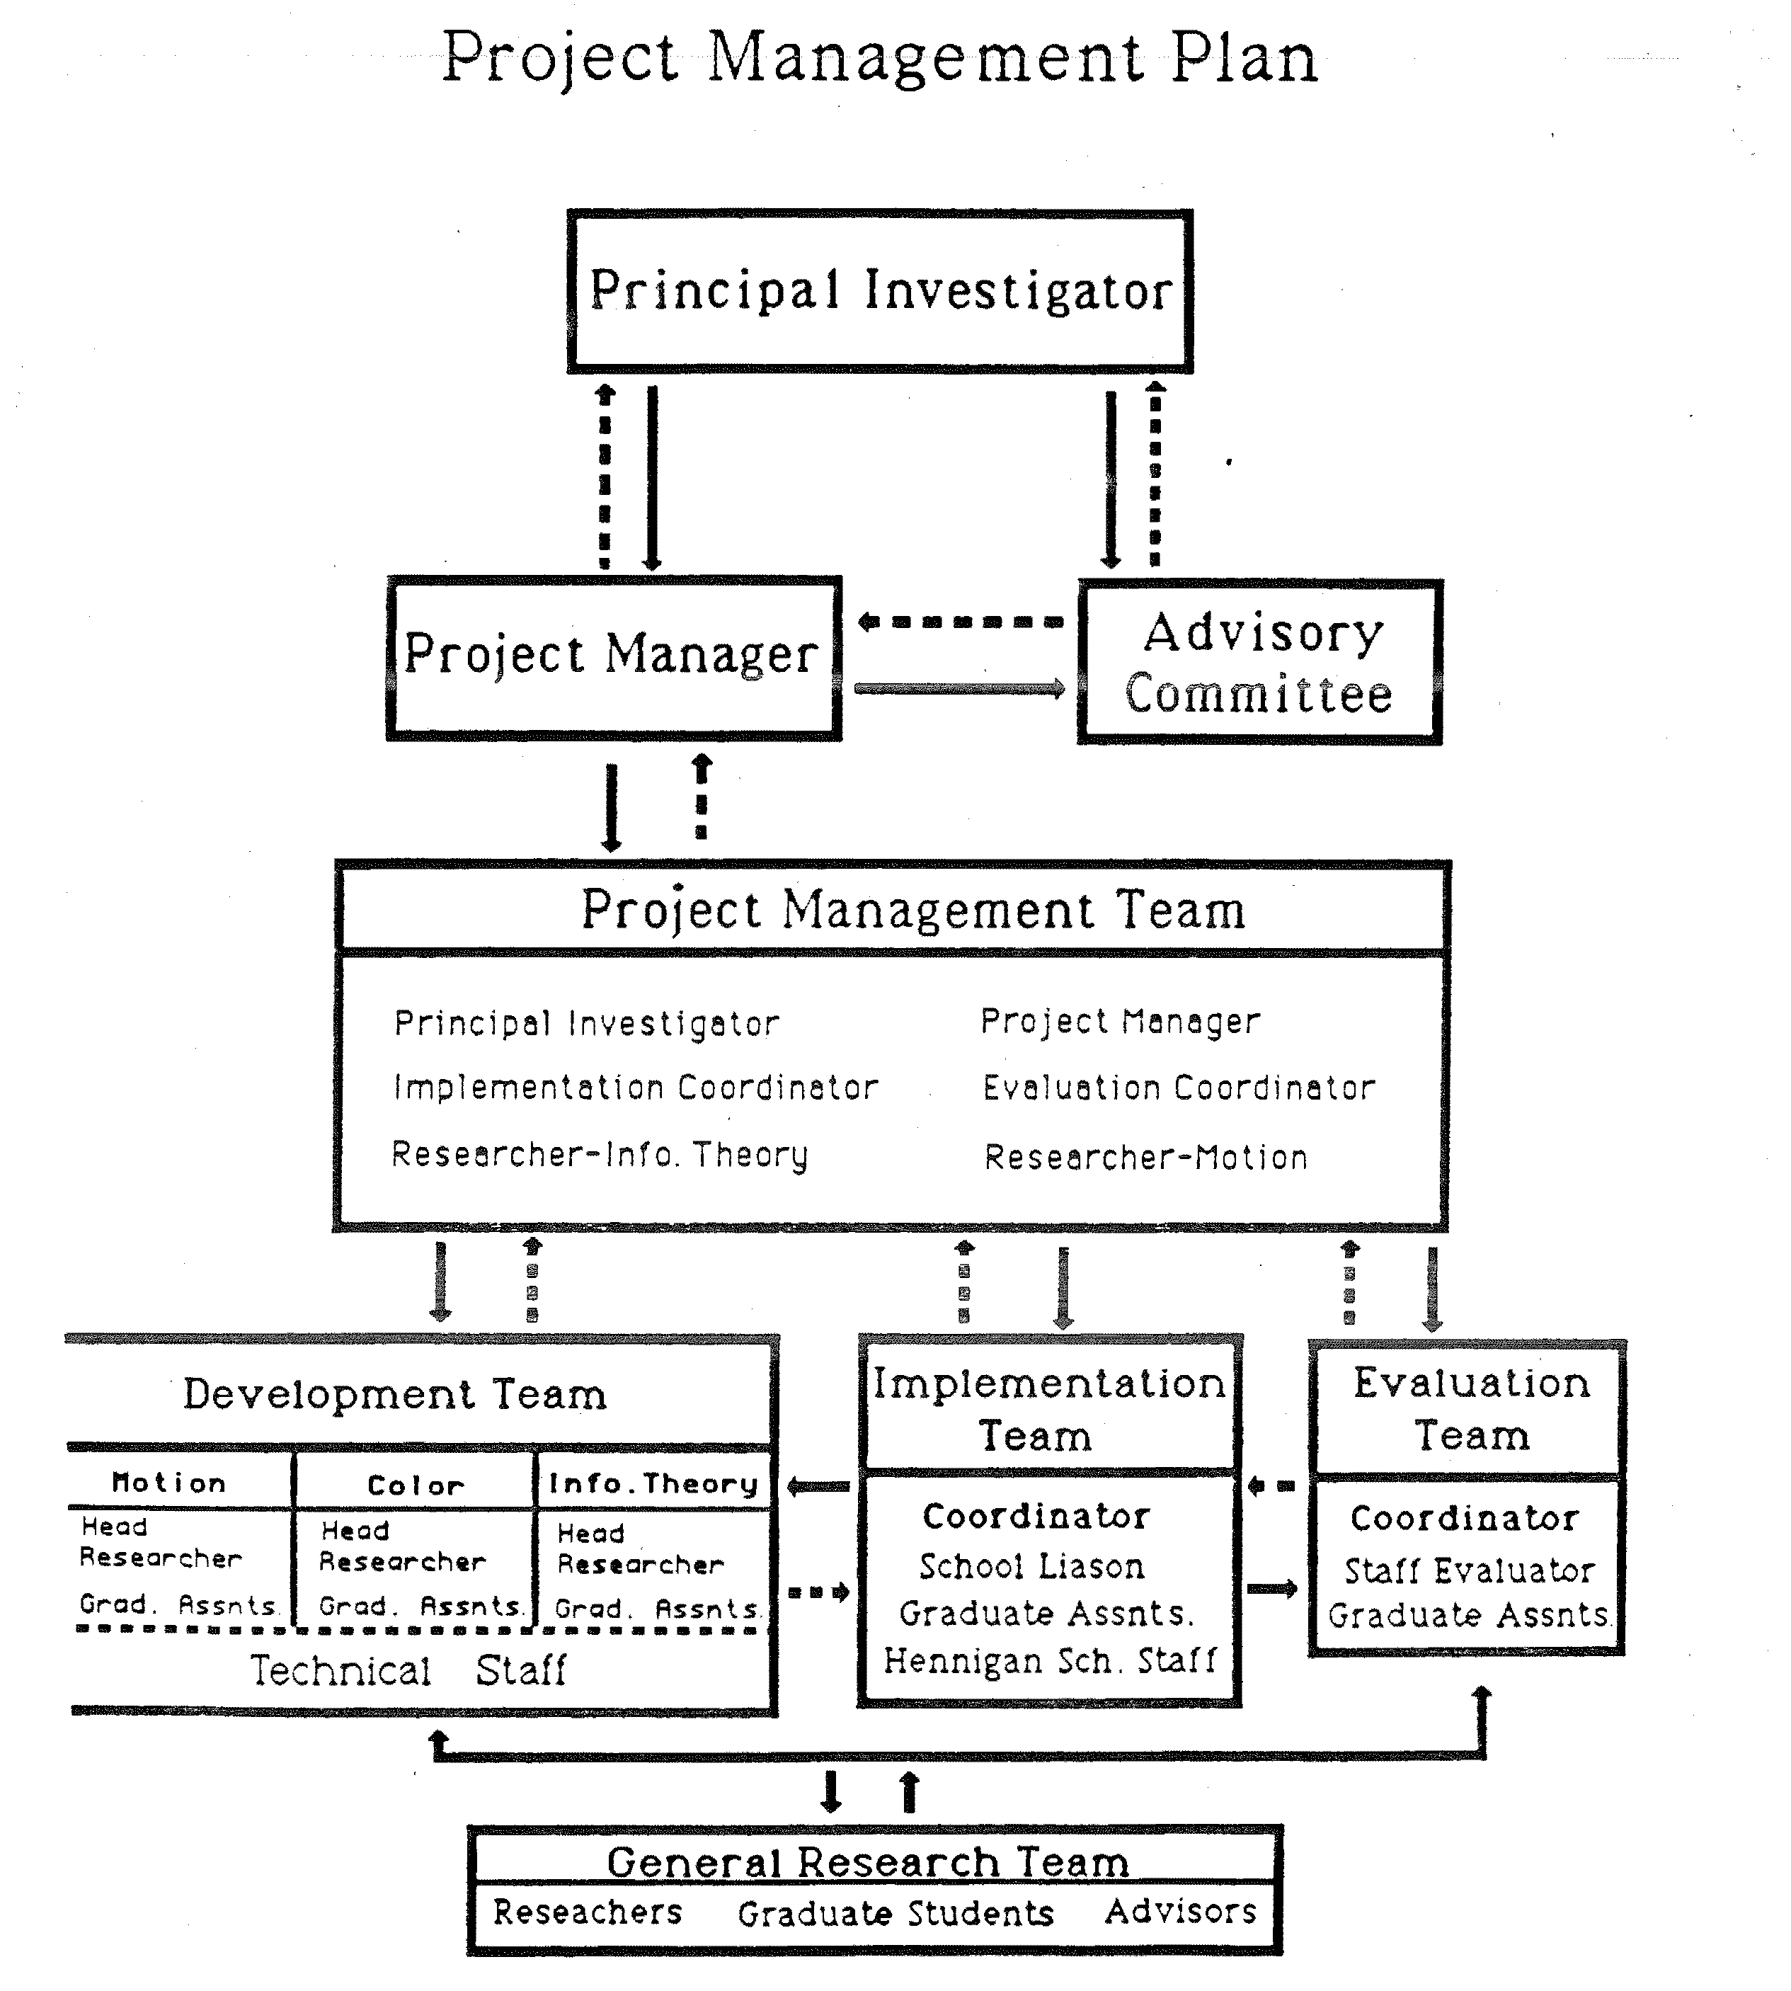

2.3.3 Project Time Lines
========================================================================================
SPRING - SUMMER 1987
========================================================================================
Activity / Task | Mar | Apr | May | Jun | Jul | Aug |
------------------------------------+-----+-----+-----+-----+-----+-----+
Recruit School Liaison, Evaluator | X | X | | | | |
Assemble Project Teams | | X | X | | | |
Prepare Evaluation Software | | X | X | X | | |
Conduct Evaluation at Hennigan | | | X | X | | |
Collate & Analyze Evaluation Data | | | | X | X | |
Develop Research Agenda (Yr 1) | | | | X | X | |
Develop Implementation Plan (Yr 1) | | | | | X | X |
Develop Evaluation Plan (Yr 1) | | | | | X | X |
------------------------------------+-----+-----+-----+-----+-----+-----+

========================================================================================
YEAR ONE: SEPT 1987 - AUG 1988
========================================================================================
Activity / Task | Sep | Oct | Nov | Dec | Jan | Feb | Mar | Apr | May | Jun | Jul | Aug |
------------------------------------+-----+-----+-----+-----+-----+-----+-----+-----+-----+-----+-----+-----+
Finalize Agenda Year 1 | X | | | | | | | | | | | |
Ongoing Research Meetings | X | X | X | X | X | X | X | X | X | | | |
Semi-Annual Review Meetings | | | | X | | | | | X | | | |
Product Group A Prep & Export | X | X | X | X | X | X | X | X | X | | | |
Product Group B Initial Research | X | X | X | X | X | X | X | X | X | | | |
Product Group C Initial Research | X | X | X | X | X | X | X | X | X | | | |
Teacher Training & Support (Grp A) | X | X | X | X | X | X | X | X | X | | | |
Evaluation & Assessment (Grp A) | X | X | X | X | X | X | X | X | X | | | |
Analyze Evaluation Data (Yr 1) | | | | | | | | | | X | X | |
Develop Research Agenda (Yr 2) | | | | | | | | | | | X | X |
Plan & Conduct Summer Institute | | | | | | | | | | X | X | X |
------------------------------------+-----+-----+-----+-----+-----+-----+-----+-----+-----+-----+-----+-----+

========================================================================================
YEAR TWO: SEPT 1988 - AUG 1989
========================================================================================
Activity / Task | Sep | Oct | Nov | Dec | Jan | Feb | Mar | Apr | May | Jun | Jul | Aug |
------------------------------------+-----+-----+-----+-----+-----+-----+-----+-----+-----+-----+-----+-----+
Finalize Agenda Year 2 | X | | | | | | | | | | | |
Ongoing Research & Review | X | X | X | X | X | X | X | X | X | | | |
Product Group A Refinement & Dissem | X | X | X | X | X | X | X | X | X | | | |
Product Group B Preparation & Test | X | X | X | X | X | X | X | X | X | | | |
Product Group C Research | X | X | X | X | X | X | X | X | X | | | |
External Evaluation (Grp A & B) | X | X | X | X | X | X | X | X | X | | | |
Analyze Evaluation Data (Yr 2) | | | | | | | | | | X | X | |
Develop Research Agenda (Yr 3) | | | | | | | | | | | X | X |
Plan & Conduct Summer Institute | | | | | | | | | | X | X | X |
------------------------------------+-----+-----+-----+-----+-----+-----+-----+-----+-----+-----+-----+-----+

========================================================================================
YEAR THREE: SEPT 1989 - AUG 1990
========================================================================================
Activity / Task | Sep | Oct | Nov | Dec | Jan | Feb | Mar | Apr | May | Jun | Jul | Aug |
------------------------------------+-----+-----+-----+-----+-----+-----+-----+-----+-----+-----+-----+-----+
Finalize Agenda Year 3 | X | | | | | | | | | | | |
Ongoing Research & Review | X | X | X | X | X | X | X | X | X | | | |
Product Group B Refinement | X | X | X | X | X | X | X | X | X | | | |
Product Group C Basic Research/Prep | X | X | X | X | X | X | X | X | X | | | |
Refine Teacher Training/Support | X | X | X | X | X | X | X | X | X | | | |
External Evaluation (Grp B & C) | X | X | X | X | X | X | X | X | X | | | |
Finalize Products & Support Matls | | | | | | | | | | X | X | X |
Finalize Research Reports | | | | | | | | | | X | X | X |
Complete Dissemination Activities | | | | | | | | | | | X | X |
Summer Institute & Final Evaluation | | | | | | | | | | X | X | X |
------------------------------------+-----+-----+-----+-----+-----+-----+-----+-----+-----+-----+-----+-----+

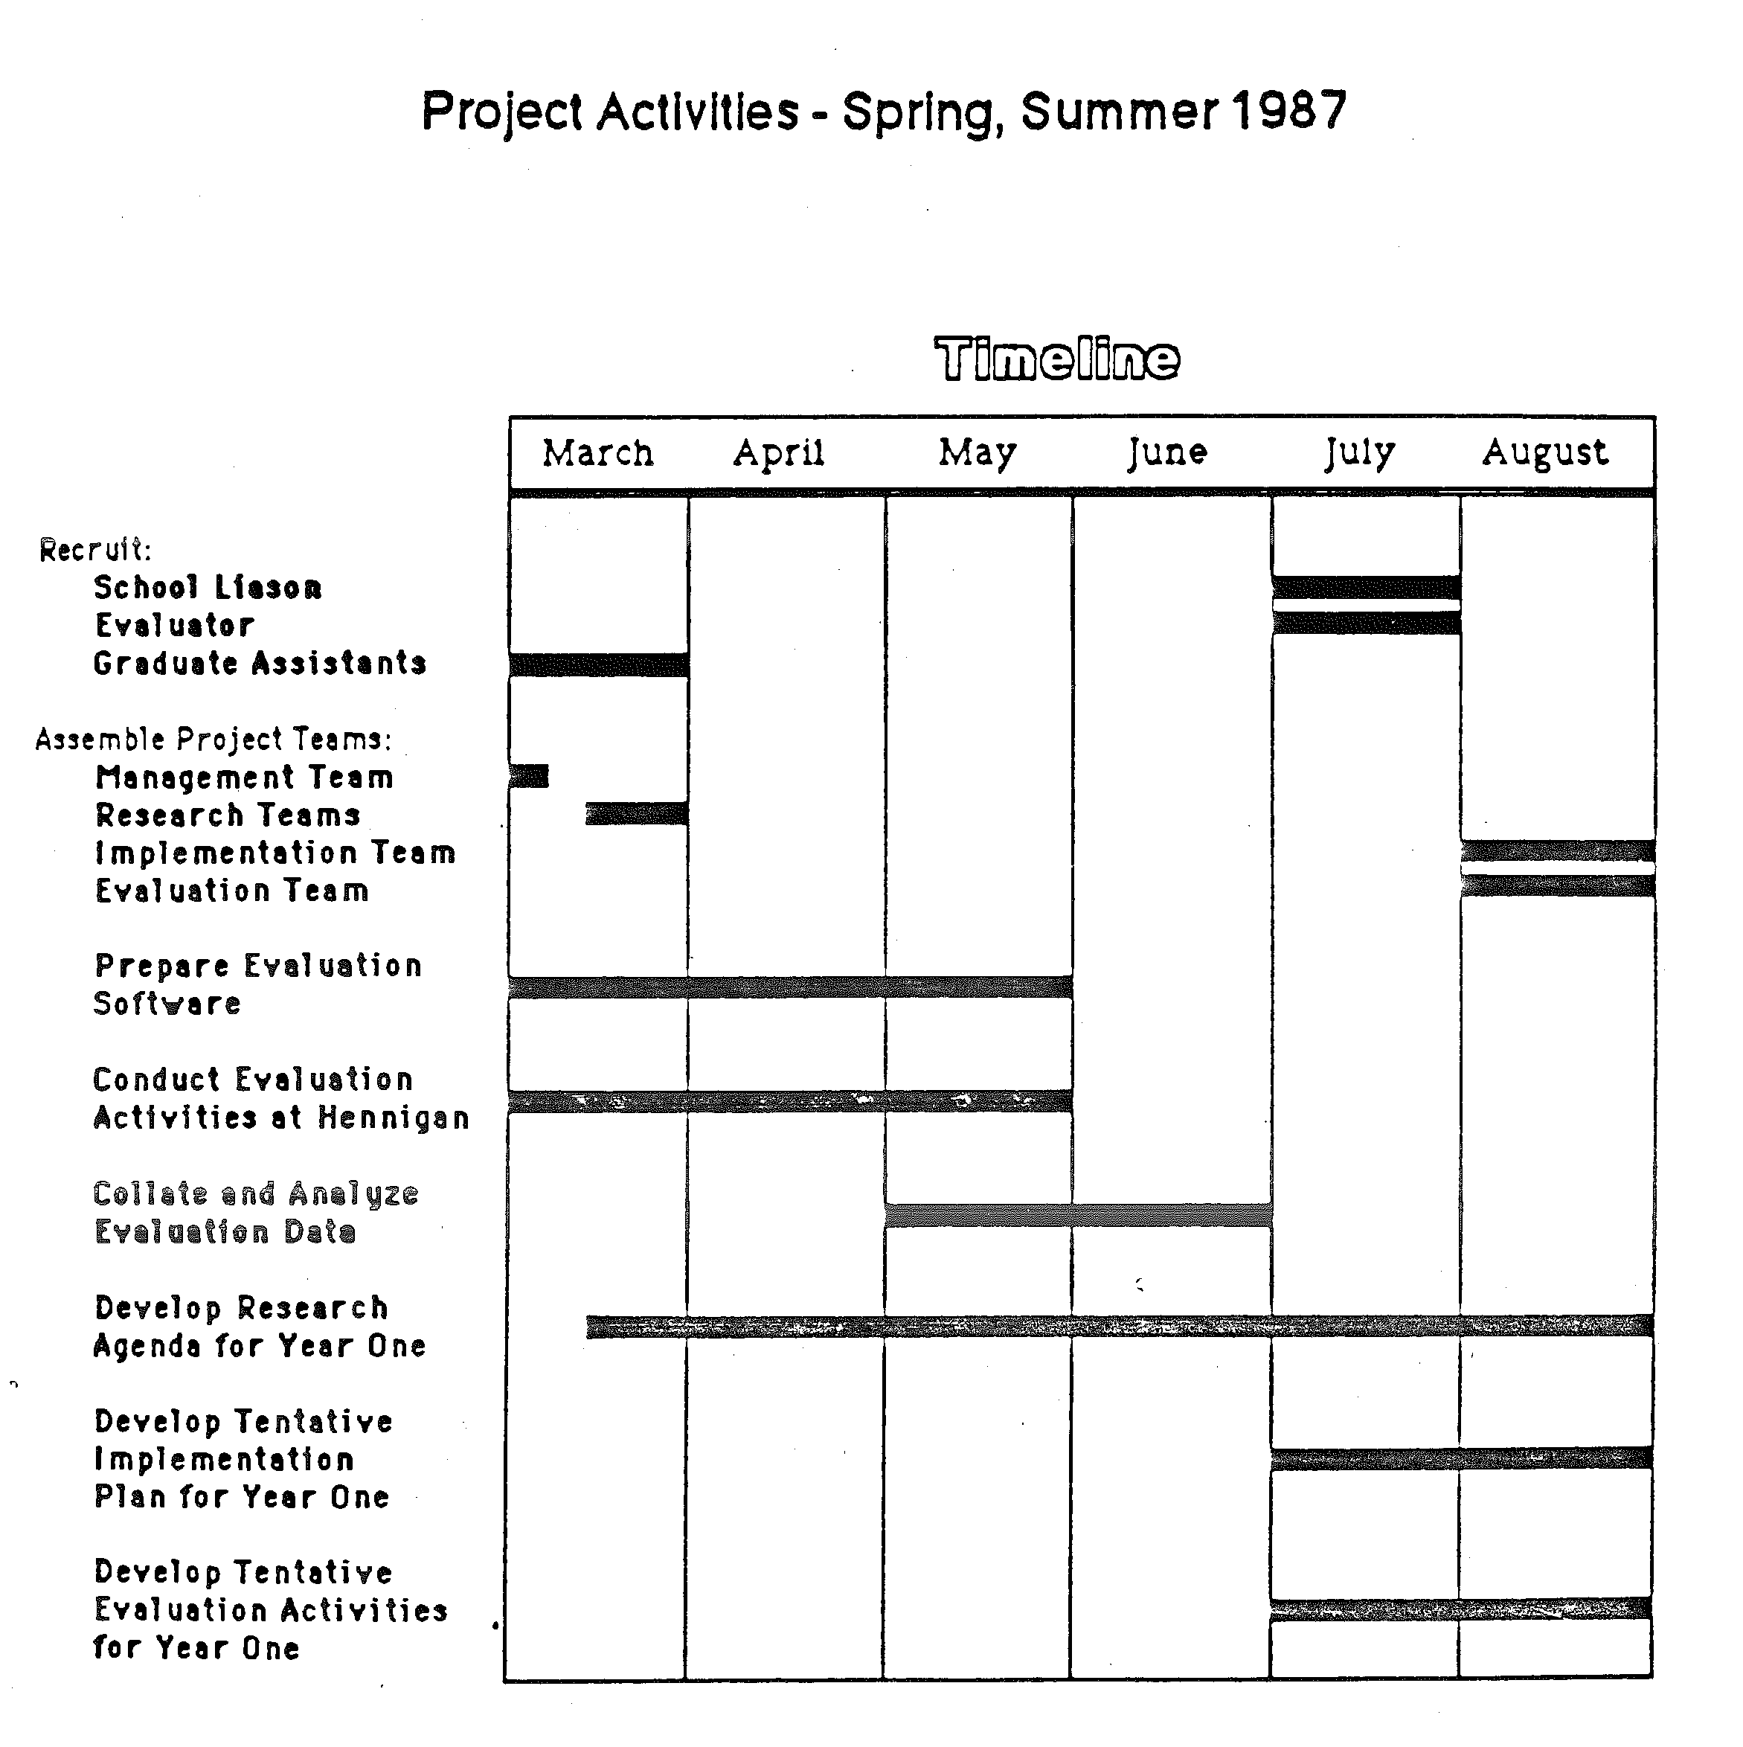

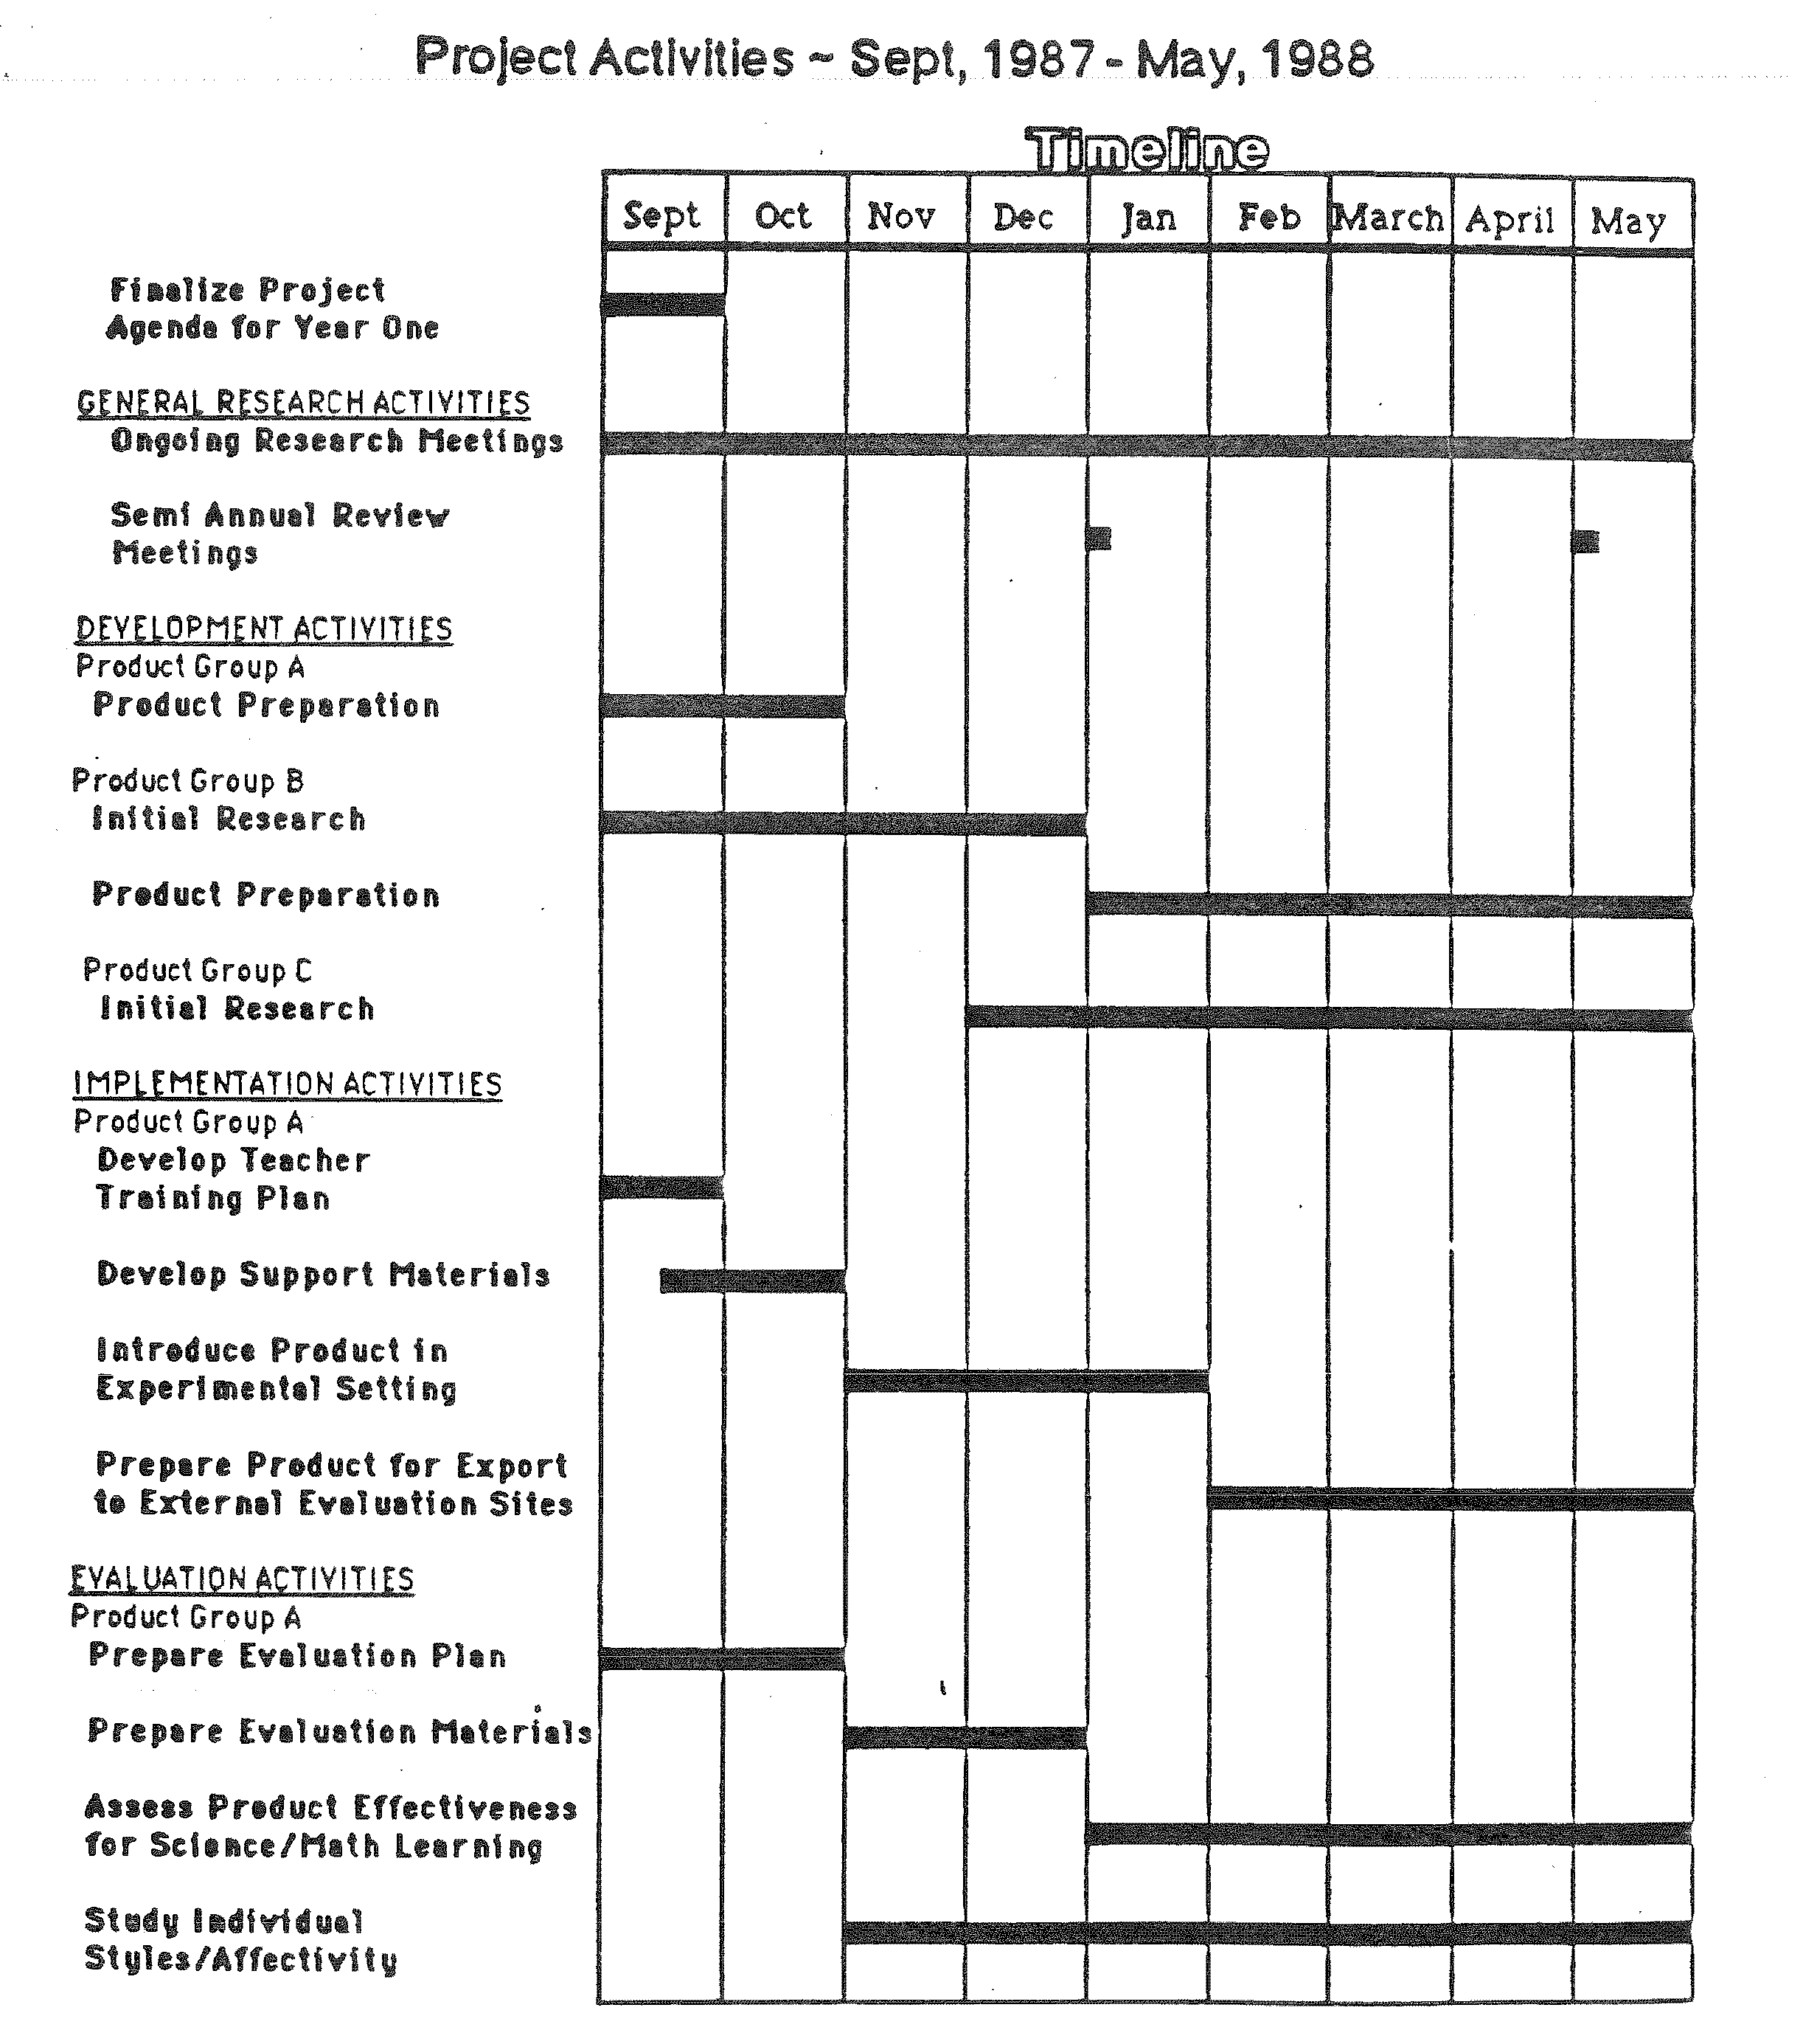

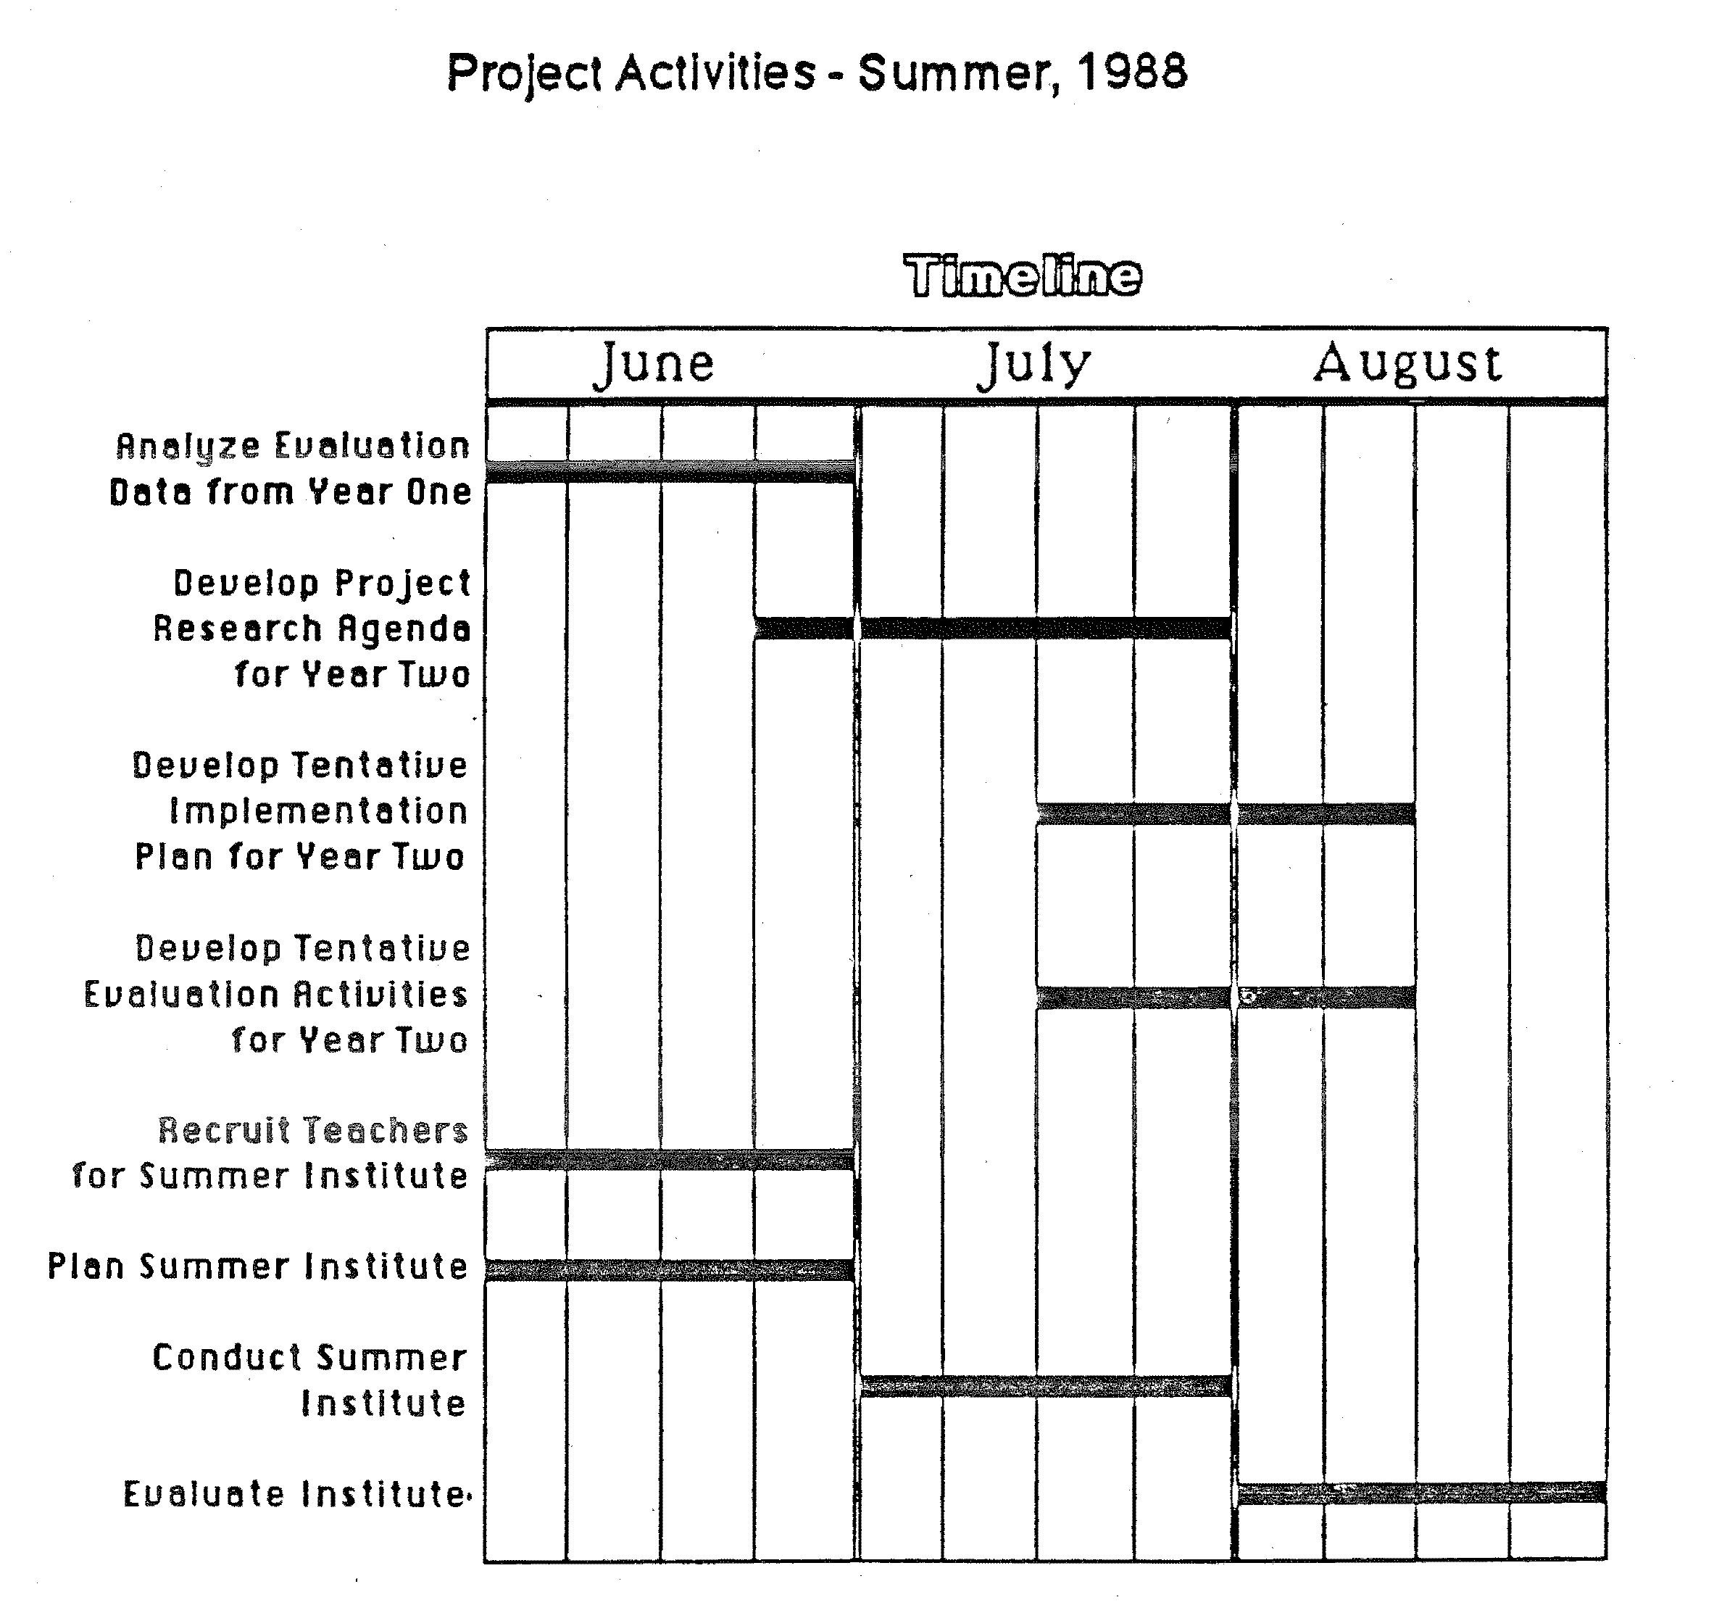

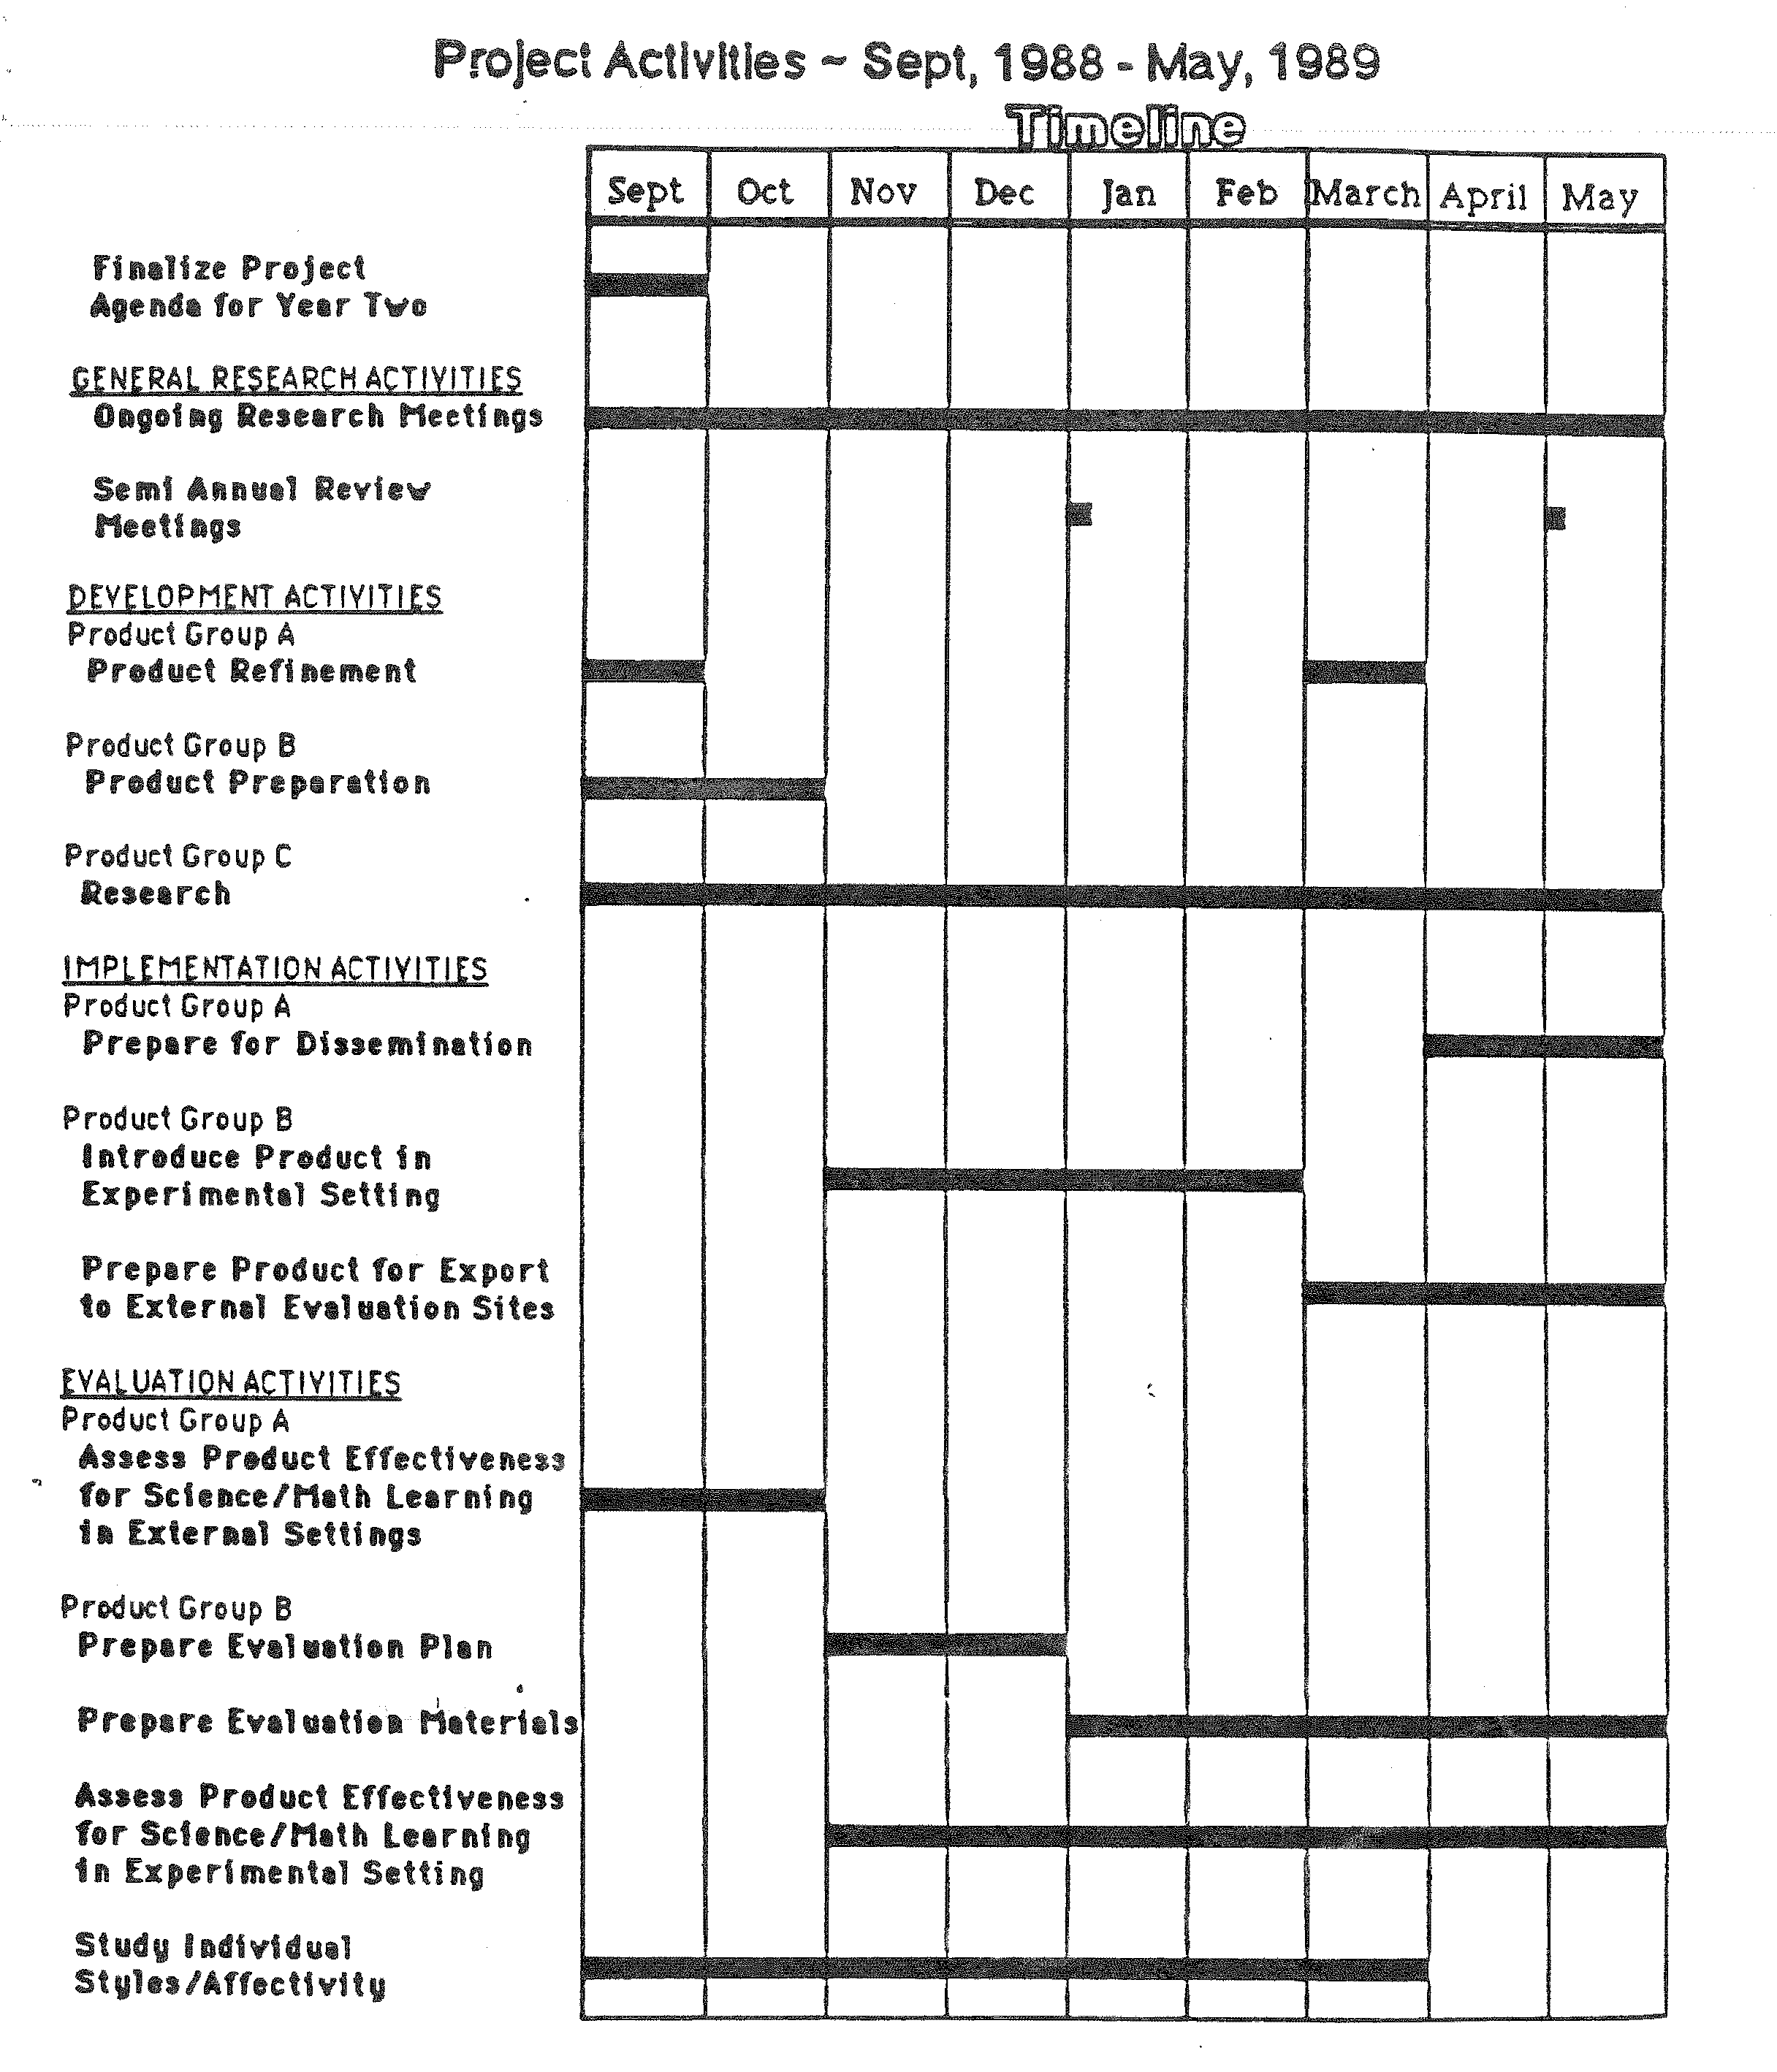

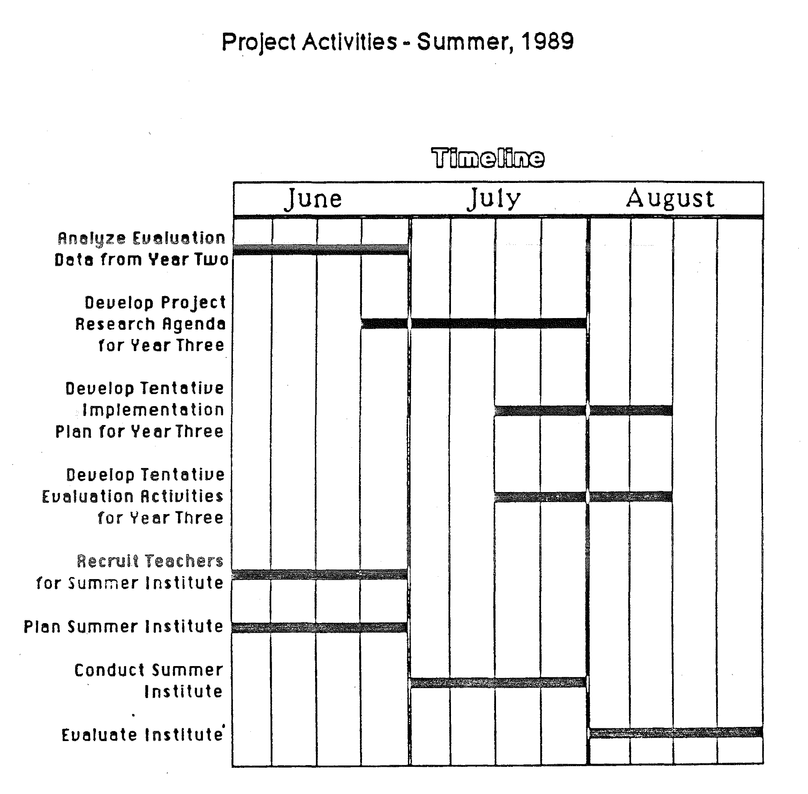

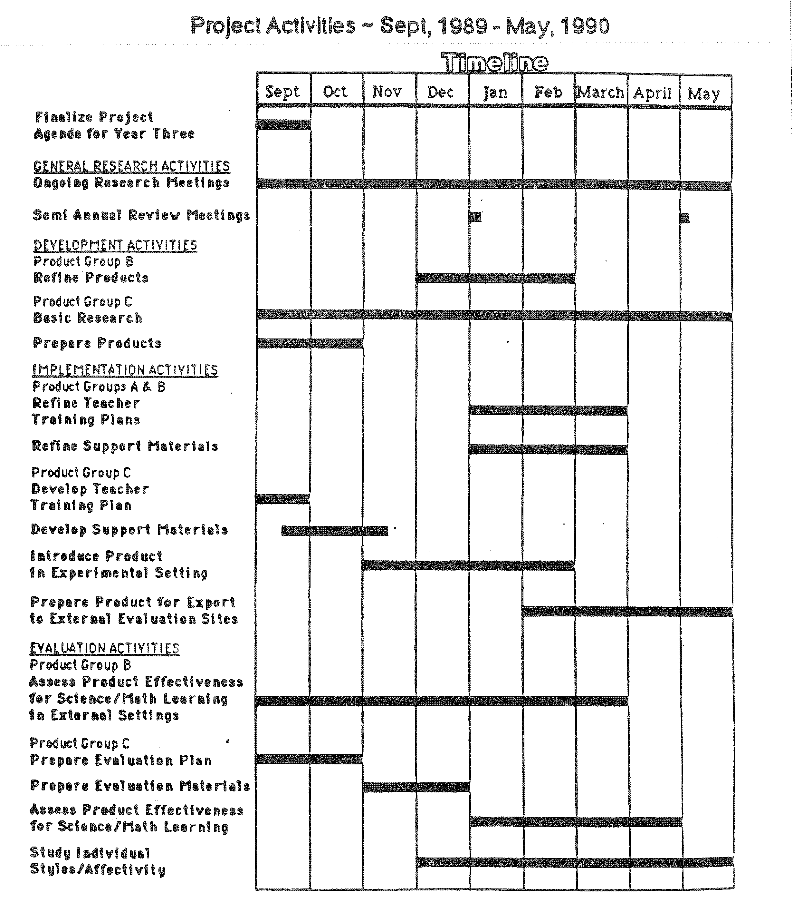

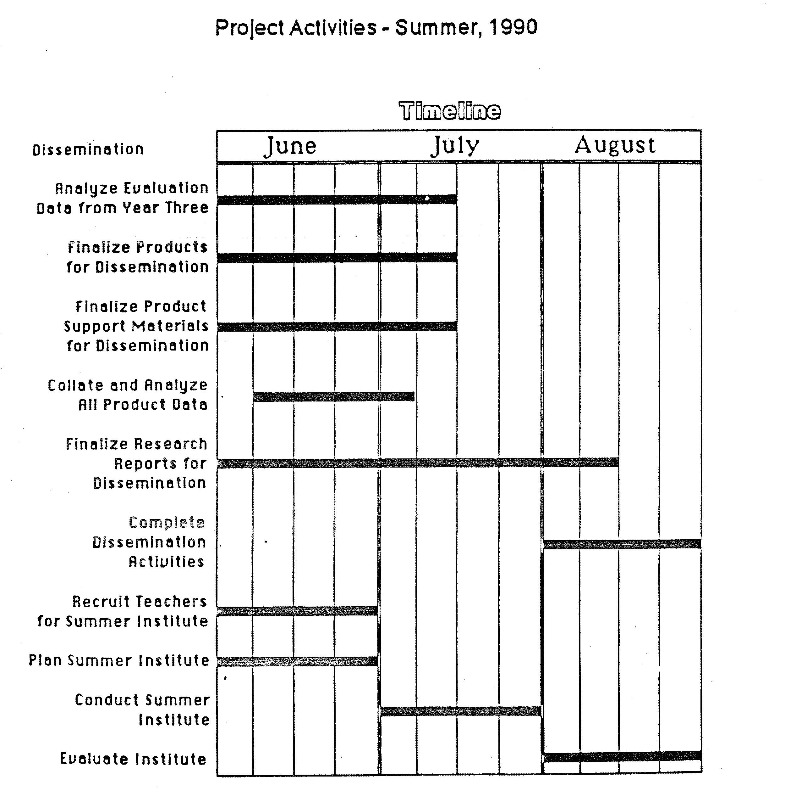

2.4 Expected Project Impact
We expect this project to make a demonstrable contribution to changing the content and focus of science activities in the elementary school, thereby enhancing the quality of elementary science education in the nation. We further expect the new science activities to support other school objectives in specific areas (including mathematics) and in general intellectual development. Indeed, our most optimistic hope is that the time in schools devoted to mathematics as a separate subject could be reduced by at least 25% and perhaps 50%. We hope to accomplish this outcome through the development of an integrated set of science activities, which will be supported by a replicable teacher training model, both of which will emanate from a well-documented sequence of research and development activities that will be shared via our dissemination activities.
During the first two years of funding, the project will have an immediate impact upon the 15 teachers and 250 students in our experimental school, as well as upon the approximately 40 teachers and 1,000 students from external evaluation sites, who will assist us in implementing and evaluating the project products.
During the third year of the project, as products are prepared for the dissemination phase, it is anticipated that approximately 500,000 students from 1,000 schools will benefit from the products developed. This figure is an estimate, based upon the fact that more than 2,000 schools have adopted LogoWriter during its first six months of availability.
In subsequent years, we think that it is reasonable to expect that the project materials will have continual adoption into the nation's elementary schools, as guides for utilizing the activities and other supporting materials continue to be disseminated by our group and as other users report their experience with the products.
In addition, we expect that the ideas and research agenda generated by the project will have continued impact on the educational community as these items are presented and debated in conferences and in print, in the form of papers, reports, and books. These expectations are based upon our previous experiences with dissemination activities. For example, Mindstorms has been read by at least 500,000 people since its publication. Also, please see the attached 148-page document listing publications concerning Logo, entitled Logo 86 Bibliography.

2.5 Dissemination Plan
One of the concerns of dissemination is to make known to the world the project's activities and outcomes. We are concerned with two types of dissemination: dissemination of research ideas and dissemination of products to help others implement those ideas.
We are in the position of being highly visible to the educational community, and receive many requests for visits to our experimental school, for reports of our research findings, and for presentations at conferences. As a result, we have established an ongoing set of successful dissemination activities that will be utilized as a model for the present project.
The Project Manager, with direction from the Principal Investigator, will coordinate the dissemination activities of the project. They will be organized into four categories which are described below:
- Preparation of Dissemination Materials: The Curriculum Specialist, with assistance from the Implementation Team, will prepare the documentation and support materials for the project products.
- Dissemination of Products to Teachers for Evaluation at External Sites: As indicated on the Project Time Lines, during the summer period of each grant year, the Implementation Team, with assistance from the Principal Investigator and the Project Manager, will plan and conduct a Summer Institute for teachers who are selected to implement and evaluate project activities at schools chosen as external sites.
- Dissemination Activities of Project Staff: Project staff will prepare written reports and papers describing project activities, and will make presentations at national conferences. Project staff will publish a series of scholarly papers as part of the dissemination plan. Also, several books and video presentations are planned.
- Identifying Commercial Partners and Placement in Mass Market: The Principal Investigator, with assistance from the Project Manager, will develop working relationships with commercial publishers appropriate with NSF guidelines. This project activity is planned to insure that materials developed during the project reach their intended audience, elementary teachers and students. This activity is also intended to provide for the continued support of project activities after the funding period. The Project Manager will be responsible for keeping NSF informed of these activities.

SECTION 3. EVALUATION PLAN

3.1 Background to an Evaluation Methodology
The observation of learners who are, or have been, engaged with the innovative material, and the analysis of what is observed, has to be at the heart of the education research. Indeed, this has become the largest component of the work of our team. However, problematic "evaluations" of Logo have led us to be wary of the "treatment model" of evaluation of the kind of educational product that interests us. We do not think that it is meaningful to study our products through experiments in which one group gets the treatment (i.e. is exposed to the materials) while a control group gets the equivalent of a placebo. Too much depends on how the new material is integrated into the total learning environment. And the remedy of trying to force the integration to be constant is too draconian and defeats the purpose of what we are trying to do: for us, the idea of educational material is one that each teacher and each learner can appropriate in a personal way.
As a supplement to the "treatment model", we have developed a methodology of close observation of children across considerable variation in teaching style. We have built a team that is now experienced in this methodology.
Two MIT faculty members who played a key role in developing the observational methodology are Professor Sherry Turkle, who has a background in sociology and in clinical psychology and has studied the psychological role of computers in many educational (and other) settings, and Professor Edith Ackermann who was recruited to MIT from the University of Geneva where she obtained her doctorate under Piaget and has taught developmental psychology and genetic epistemology. MIT researchers include Dr. Sylvia Weir, a physician who has worked for many years with psychologically and physically handicapped students. During the time the methodology was being developed the team had the half-time services of Frank Basa who is an expert on quantitative testing methods. Consultants who contributed significantly have included Dr. Guida Wilder and Dr. Ted Chittenden from ETS, Professor Douglas Clements from Kent State University, Professor William Higginson from Queen's University in Toronto, and Professor Celia Hoyles and Dr. Richard Noss from the London Institute of Education.
The essential goal of our evaluational work is to understand as deeply as possible the individuals involved, teachers and students, and to follow in the greatest possible detail the actual process of learning. At the Hennigan School during the past two years, we have tried to do this by the following highly "observer-intensive" method:
Each graduate student and staff member in the project is assigned a small number of children. The observer is expected to spend an hour a week working with the child (as part of some aspect of the teaching component of the project), to collect samples of the child's work in regular classes, to interview the teacher once a semester, and, if possible, to meet the parents. In addition, the child is interviewed and given a battery of tests by a professional psychologist including: parts of the WISC; tests of cognitive style; Test of Creative Thinking; Peabody Picture Test; and several projective tests.
Clearly, only a relatively small number of students can be studied as intensively as this. However, we have found that doing so deepens the interpretation of other, more easily administered methods of collecting data, such as written tests, questionnaires and standard school achievement scores. The method consists of collecting some kind of data for everyone in the school, and then selecting a sample of 30 students for the most intensive study. Individuals from the larger group who show interesting behaviors are investigated at an intermediate level.
Subjects are drawn from the experimental group in our project, and a control group consists of students with similar background and academic level.

3.2 Application of the Methodology
The intensive psychological study goes well beyond the goals of standard educational evaluation. To give a concrete case of how our goals are more complex we take once again the model of Lego-Logo.
Early in our work we fixed on the idea of building a learning model in which elementary school children of all ages could work with Lego-Logo. We did not know how much children at different ages would learn or how long they would take. These Level One questions were answered as part of the evaluation process. So was the question of how teachers and others involved in the process would perceive the work. Would they see it as play and not serious? Would they perceive it as helping children learn other things, or develop in other specific ways (such as improvement in self-image)? Would they see it as something that would benefit them in their teaching of other subject matters?
We addressed these questions by setting up trial classes at several distances from the research team. The first round consisted of classes run by our Researchers in the Hennigan school with the teacher present as an "apprentice". The next round was still in the Hennigan school but with the teacher in charge. Then we moved out of the Hennigan school, working first with teachers we knew and who knew our methods; later, with teachers who had been given only a one day workshop and a video tape in addition to the written teachers guide that is part of the materials. We are now collecting data on attempts by teachers who had no direct contact with us at all.
Level Two evaluation bears on what uses students and teachers make of the Lego-Logo experience. This requires a more open-ended and subtle kind of observation, for each person will use the experience in a unique personal way. For example, a teacher reported that the Lego-Logo experience improved her class' ability to learn how to add fractions (compared with previous classes and with this class performance on other similar topics). It is easy to verify the fact that the children did well. But Level Two evaluation looks at the underlying process: Did the improvement come directly from what the children did with Lego or did it come via effects on the teacher? In either case one can ask how much of the improvement is due to cognitive factors (Lego gears might be a good model for ratio) and how much can be traced to affective factors (better feelings about self, about fractions, about school or about the people involved). Another aspect of Level Two observation looks for interactions between different learning experiences that we have introduced. For example, Lego-Logo supports different components of Logo programming skill than does more traditional Logo work; so doing the two leads more quickly to a higher level of Logo ability.
The third level of evaluation looks more deeply at individual psychological process. We observed a number of girls do surprisingly well (in terms of what was known about their past interests) on problems involving mechanisms. A close psychological look suggests that this was related to these girls' interest in what lies behind the surface of human actions. In other cases we correlate certain kinds of Lego performance with being able to "get inside the situation", and this in turn with an individual's propensity to "identify" with objects.

3.3 Evaluation Plan of Present Project

3.3.1 Individual Products
Level One observation will follow closely the Lego-Logo model. The first round of observations is always made by the research team that is developing the module. When the module is taking firm shape the evaluation coordinator makes a plan to bring the evaluation team more closely into the picture, and the responsibility shifts progressively from the original developers to the evaluation team. The systematic evaluation takes place in the following years as shown schematically in the time line charts.
Level Three evaluation will be conducted only at the Hennigan school (shown in the time lines under the general research) where we can observe a sample of children intensively over a three-year period as well as make the more limited observations relevant to Level One. In the case of Level Three work, the children observed are not generally chosen specifically for each module (though in some cases they might be if the researcher in charge has special concerns). Using the same children for several modules has the obvious "disadvantage" of not allowing us to isolate the effects of one experience. However, it may really reflect an essential property of human learning, rather than any limitation of a particular method of observing it.
Level Two observations will be conducted in a form intermediate between the other two.

3.3.2 Evaluation of the Ensemble
Our weak thesis is that individual modules based on Constructionist principles will incrementally enhance science learning. Our strong thesis is that a well conceived, mutually supportive set (such as the one we propose) will radically change the learning of science and its interaction with other school learning. The strong thesis will be evaluated by observing the development of the Hennigan school as a whole. We plan to track the progress of the school in a three-year longitudinal study (for which we already have base level data) paying particular attention to the following:
- (A) Enthusiasm for science:
  - Measured by attitude scales and by how much science students choose to do.
  - Measured by content analysis of students' discourse and reasoning: for example, do references to science occur spontaneously in the course of discussing other things?
- (B) Extent of science learning:
  - Extent of standard curriculum.
  - Extent of science picked up from the general culture.
  - Extent of material contained in our modules.
- (C) General scholastic achievement:
  - Measured by standard scores.
  - Analysed as far as possible by Level Three-type studies with contributions from the new materials we have added.
- (D) Moral and Social atmosphere of school.

3.3.3 Our Social Goals
Finally, we declare only in the most general terms our intention to address the problem of measuring the effect of our work on the "aspiration level" of science education. The simplest part of this study will be to track, through questionnaires and interviews, the attitudes of teachers attending our training sessions. But beyond this, our ambition is to find ways to follow whether our work is having a noticeable effect on the national consensus of what science can be learned by whom.

3.4 Procedures
The Project Evaluation Team, under the direction of the Principal Investigator and the Project Manager, will be responsible for conducting the evaluation activities of the project. As each product is developed by the research staff and introduced into Hennigan School, the Evaluation Coordinator will devise a specific assessment plan to measure its effectiveness.
The Evaluator, with the help of two graduate assistants, will collect and collate the relevant data and assist the coordinator in the analysis and reporting processes.
This team will conduct their evaluation activities on an ongoing basis throughout the duration of the project. This basically internal evaluation plan was chosen in order to provide continual feedback to the research and implementation staff as they plan and conduct their activities. It is expected that these procedures will result in a program which will flexibly respond to accomplishing the objectives of the project. Further, it is anticipated that the evaluation plan itself will be a useful product to be disseminated at the completion of the project.
The Evaluation activities are further specified in the Project Time Lines.

SECTION 4. PERSONNEL
- Principal Investigator: Seymour Papert, Professor of Media Technology, MIT, will serve as principal investigator of the project, for 25% FTE. He will oversee the entire project, including the selection of needed personnel and graduate assistants, and will guide the research, implementation, and evaluation phases of the project.
- Project Manager: Marilyn Schaffer, Associate Professor of Early Childhood Education and Coordinator of Educational Computing at the University of Hartford, W. Hartford, CT, has agreed to take on this function for 100% FTE. The Manager's duties will include coordinating the development, implementation, evaluation, and dissemination activities of the project, under the direction of the principal investigator.
- Evaluation Coordinator: Edith Ackermann, Assistant Professor, The Media Laboratory, MIT, will coordinate the evaluation activities of the project, under the direction of the PI, and with the support of the Evaluation Team and the Project Manager. She will devote 50% FTE to the project.
- Specialist on Learning Difficulties: Sylvia Weir, Principal Research Scientist, The Media Laboratory, will review all activities from the perspective of learning difficulties. She will also coordinate the implementation activities of the project, under the direction of the PI, and with the support of the Implementation Team and the Project Manager. She will devote 50% of her time to the project. Sylvia Weir is also a specialist on special education and will advise the project as a whole on its relationship to special educational needs.
- Advisor on Social Sciences: Sherry Turkle, Associate Professor of Science, Technology and Society, MIT. Professor Turkle will not be in the NSF budget.
- Researcher-Motion Studies: Stephen Ocko, Research Associate, The Media Laboratory, MIT, will devote 50% FTE to directing and conducting the grant activities involving motion research, with assistance from two graduate students and the technical staff.
- Researcher-Color Studies: The Principal Investigator will serve in this position, directing the activities involving color research, with the assistance of two graduate students and the technical staff.
- Researcher-Information Theory Studies: A senior person will be identified, who will devote 50% FTE to directing and conducting the grant activities involving information theory research, with assistance from two graduate students and the technical staff.
- Curriculum Specialist: A person will be recruited to prepare the documentation and support materials such as teacher and student guides for each of the products generated, and to assist in preparing the teacher training materials. He/she will devote 100% FTE to the project.
- School Liaison: In collaboration with the Hennigan School administration, a teacher will be selected to serve as the liaison between the project staff and the school. He/she will devote 100% FTE to working with the Hennigan teachers to implement the project activities. His/Her salary will be shared by the Boston Public School Department.
- Evaluator: An evaluator will be selected to carry out the observation and evaluation activities at Hennigan School, with direction from the Evaluation Coordinator and assistance from two graduate students. He/she will devote 100% FTE to the project. A criteria for choosing the evaluator will be expertise in minority and gender issues.
- Graduate Assistants: Ten graduate assistants will be selected to assist the project staff as they conduct the grant activities. (However, only six will be supported with funds from the present grant; the remaining four will be supported with non-NSF funds.) Six assistants will work on the research activities, two with the implementation staff, and two with the evaluation team. Graduate students in the Epistemology and Learning Group specialize in very different areas including technology, psychology and art. The quality of our graduate students is illustrated by a sample of vitae.
- Technical Staff: Mario Bourgoin, Engineer, Media Technology, MIT, will devote 50% of his time to providing technical support to the project; in addition, technical assistance to support specific research projects will be drawn from staff of the Media Technology Lab for an equivalent of 50% FTE.
- Advisory Committee:
  - Sherry Turkle, Professor of Sociology, Program on Science, Technology and Society, MIT, will serve as advisor on Social Sciences;
  - Alan Kay, Adjunct Professor, Media Technology, MIT, will serve as a resource to the project in the area of Computer Interfaces;
  - Marvin Minsky, Professor of Science, MIT, will serve as advisor in Artificial Intelligence;
  - If funded, we shall invite the following people (or request equivalent if any are not available):
    - Robert Tinker, Technical Education Resource Center, Cambridge;
    - Andrea diSessa, Professor of Science Education, Berkeley, will advise the project staff concerning science learning;
    - Laval Wilson, Superintendent of Schools, Boston, will serve as an advisor on education issues;
    - John Ladd, Professor of Education, UCLA, will also advise the project staff concerning issues relating to education.

